Welcome to Brownback’s

United Church of Christ

640 Ridge Road
Spring City, Pennsylvania

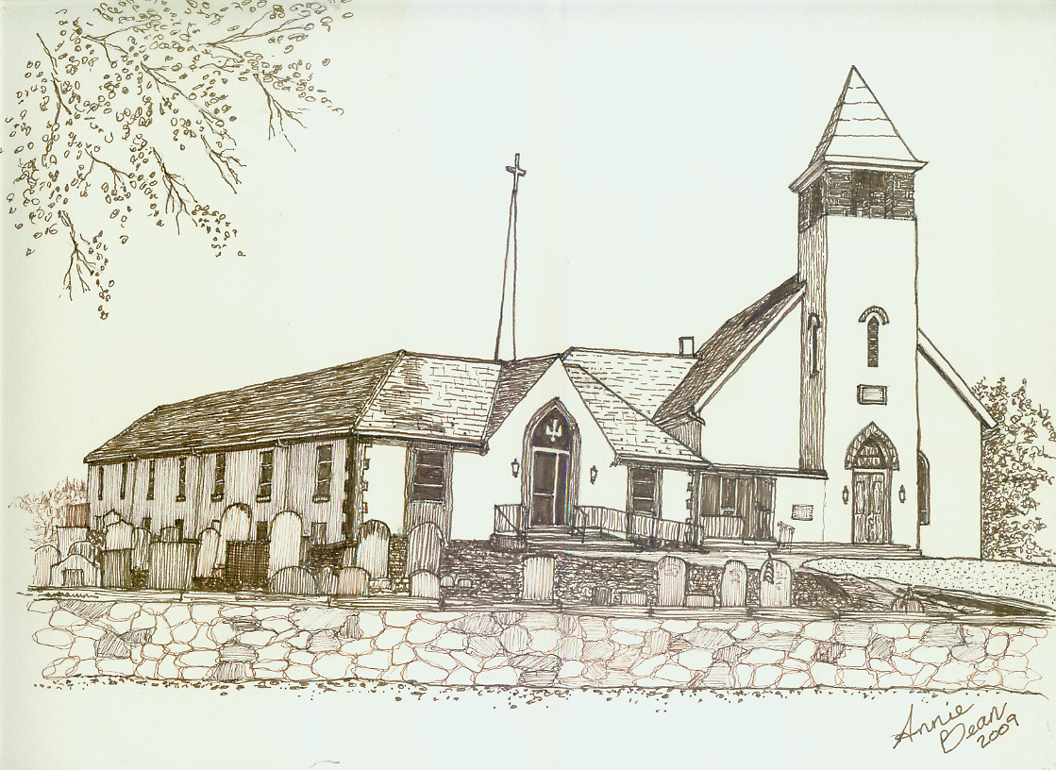

Second Sunday in Lent
March 8, 2020 10 a.m.
Welcome
We are glad you’re here to worship with us today.
This program has been especially designed
to enable you to participate fully in our Service.
May this be for you a time of refreshment and renewal.

ANNOUNCEMENTS

PRELUDE Beautiful Savior Paxton
Please use this time for quiet meditation before worship.
During the Service, the people will make the responses in the bold print.

CALL TO WORSHIP adapted Psalm 121
All who are able may stand as we open our worship.
I lift my eyes up to the mountains,
from where will my help come?
My help comes from the Lord,
who made heaven and earth.

God will not let your foot be moved,
God who keeps you will not slumber.
God who keeps Israel will neither slumber nor sleep.

The Lord is your keeper,
the Lord is your shade at your right hand.
The sun will not strike you by day nor the moon by night.
The Lord will keep you from all evil,
the Lord will keep your life.
The Lord will keep your going out and your coming in
from this time on and forevermore. Amen.

HYMN 287 Lift High the Cross CRUCIFER
After the hymn, please be seated.

INVOCATION
As we settle into this time of worship and praise,
may we now join together in the spirit
of praying our confession.

PRAYER OF CONFESSION God of Wisdom,
we come to You confessing our human brokenness.
We all know what we have and have not done
that is not according to your will, God.
We know that life’s decisions,
human urges to survive and rise above
do tend to affect all of us.
We are always seeking to be one in Christ
and one in community.
We ask for your ongoing forgiveness
as we continue to offer our confessions to You
in this moment of silence…

ASSURANCE OF PARDON
Brothers and sisters in Christ,
we have joined today to worship,
to confess our weaknesses
and pray for God’s forgiveness to continue to speak to us.
Know that we are forgiven,
because we know and follow Jesus in our hearts
and on our daily paths
and may the love of God continue to guide us every day. Thanks be to God.

GLORIA PATRI GLORIA PATRI
Glory be to the Father, and to the Son, and to the Holy Ghost;
as it was in the beginning, is now, and ever shall be,
world without end. Amen. Amen.
PASSING THE PEACE
The Peace of Our Lord Jesus Christ be with you.
And also with you.
Let us exchange with one another a sign of Christ’s peace, and then be seated.

ANTHEM I Will Follow*
Worship Ensemble

PRAYER OF THE DAY

A READING FROM THE LETTERS Romans 4:1-5, 13-17
Pew Bibles, Page 1751

A READING FROM PSALM 121
I lift up my eyes to the mountains—
where does my help come from?
My help comes from the Lord,
the Maker of heaven and earth.

He will not let your foot slip—
he who watches over you will not slumber;
indeed, he who watches over Israel
will neither slumber nor sleep.

The Lord watches over you—
the Lord is your shade at your right hand;
the sun will not harm you by day,
nor the moon by night.

The Lord will keep you from all harm—
he will watch over your life;
the Lord will watch over your coming and going
both now and forevermore.

ANTHEM Jesus Messiah arr. Larson
Chancel Choir
HOLY ACT OF BAPTISM – WESLEY MAVERICK FREEMAN
In this sacrament, we welcome to the family of God’s people
Wesley Maverick Freeman, son of Paige and Andrew Freeman,
grandson of Rick and Jeanette Francesco,
on this 8th day of March in the year of our Lord, 2020.

THE GREETING
Our Lord Jesus Christ has called us to himself and has commanded that we be baptized. Through baptism we are joined to Christ, and become part of his family, the church. Through this sacrament and in community, we have new birth through water and the Spirit and a share in all the marvelous gifts of God. All of this is from God and for all of God’s children but today, it is for Wesley Maverick Freeman.

PROFESSION OF FAITH/PARENTS’ AND GOD-PARENTS’ PROMISE
Paige, Andrew, Trent and Amanda, baptism we know is a sacrament, an outward and visible sign of God’s boundless grace and a celebration of God’s unconditional and never-ending love. It is also a promise-making time.

Do you promise your love and support to Wesley as he journeys through this life and what it means to be a disciple of Christ?
Parents’/Godparents’ response: We promise, with God’s help, to reflect God’s “no strings attached,” endless love in our relationship with Wesley.

Baptism is also a christening, as it completes the naming process. To the name of Wesley Maverick that he has been given, we will add the name, Child of God, member of God’s family. In light of that process, will you seek to help Wesley come to know who he is at the most deepest and basic level?
Parents’/Godparents’ response: We will, with God’s help.

Baptism is also about anticipation, a looking forward to the beginning of their growth into full Christian Faith and discipleship. As you anticipate the time when Wesley will confirm his decision to live in the power of God’s love and grace and to follow the ways of Christ, will you continue to nurture and encourage, through steadfast love and prayer and prepare Wesley for that time?
Parents’/Godparents’ response: We will, with God’s help.

Will you, the family and friends gathered here today, witnesses to this sacrament of baptism into God’s loving and ever-growing family, support all of us in this commitment and become a special friend and faith partner to Wesley?
Family response: Yes, we will.

COMMITMENT OF THE CHURCH
All who are able may stand.
Will you, the congregation of Brownback’s United Church of Christ, promise your ongoing support, friendship, prayers, love, and availability to Paige and Andrew as they raise up Wesley into this faith body?
People: Yes, we promise our love, support and care. With God’s help we will surround Wesley with a community of love and forgiveness, that he may grow in service to others. We will pray for him that he may be a member of God’s family, who walks in the way that leads to everlasting life.

AFFIRMATION OF FAITH The Apostles’ Creed
I believe in God, the Father Almighty,
creator of heaven and earth.
I believe in Jesus Christ, God’s only Son, our Lord,
who was conceived by the Holy Spirit,
born of the Virgin Mary,
suffered under Pontius Pilate
was crucified, died, and was buried;
he descended to the dead.
On the third day he rose again;
he ascended into heaven,
is seated at the right hand of the Father,
and will come again to judge
the living and the dead.
I believe in the Holy Spirit,
the holy catholic church,
the communion of saints,
the forgiveness of sins,
the resurrection of the body,
and the life everlasting. Amen.
Please be seated.

THANKSGIVING OVER THE WATER
In the spirit of Christ, may we now join in prayer.
Eternal God,
we know that the promise of the Gospel
is to all of your children.
We pray that you bless this water through the Holy Spirit
and your presence around us this morning,
gracious God, and create a new life
in Wesley Maverick Freeman.
May this everlasting glory from you, eternal God,
the one who was, and is, and shall always be,
world without end. Amen.

ACT OF BAPTISM
Wesley Maverick,
we now baptize you in the name of the Father,
and of the Son, and of the Holy Spirit.
As you are now marked with this sign of the cross,
you are marked as Christ’s own forever.
May you be filled with the Holy Spirit
and receive these in your life:
A child of God,
a disciple of Christ everlasting
and member of the church universal.
And may you also receive the light of Christ, Wesley,
for you have passed from darkness into light through Jesus Christ, our risen Lord and Savior.

PRAYER FOR THE BAPTIZED
We give you thanks, God,
for Wesley Maverick
and for the grace acknowledged here today
in both water and the Holy Spirit.
Grant us grace to receive, nurture,
and befriend this new member of the body of Christ.
Give to the newly baptized:
strength for life’s journey,
courage in time of suffering,
the joy of faith,
the freedom of love,
and the hope of new life;
through Jesus Christ,
who makes us one in body and Spirit. Amen.

HYMN 553 Go to the World! ENGELBERG

A WORD FOR ALL AGES
All children may come forward at this time to gather with Pastor Mark.
Those through Grade 6 will then be dismissed to Worship Play.

GOSPEL READING John 3:1-17

SERMON Born of the Spirit Rev. Mark L. Stryjak

HYMN 61 There’s a Wideness in God’s Mercy WELLESLEY
After the hymn, please be seated.

GIVING AND RECEIVING OF TITHES AND OFFERINGS
Kindly hand your prayer request cards to the ushers.
At this moment, we come before God to offer to God. We offer not out of necessity but because we genuinely care for all people. May we make that known this day and forevermore. Amen.

OFFERTORY Tranquillo Beethoven

PRESENTATION
All may stand as the offering is presented
and remain standing for the hymns and prayer that follows.

HYMN 34 OLD HUNDREDTH
Praise God from whom all blessings flow;
Praise Him all creatures here below;
Praise Him above, ye heavenly host;
Praise Father, Son, and Holy Ghost. Amen.

PRAYER OF DEDICATION
Holy God,
we have gathered as one congregation
and faith family to help
sustain your Son’s mission in this piece of the world.
What we offer, we pray,
is that these resources find the places
of greatest need and that we continually
do all that we can,
in Christ’s name now and forevermore.
In Jesus’ name we pray. Amen.

PRAYER HYMN 477 Come and Find the Quiet Center BEACH SPRING
We will sing verse 1 only.
After the hymn, please be seated.
PRAYERS OF THE PEOPLE
Holy One, we quiet our minds and thoughts to pray for the countless people who are trying to find food and water, shelter and care in the midst of their daily life.

We know the needs are great and yet we are only aware of a small percentage of that need and so we pray for all people to come together, to care and show compassion in the daily struggles that so many people face.

We pray for our faith to always rise above the fears of the world. The ongoing fears today of viruses, election anxiety and daily life all pose threats to us. What is the balance of protecting ourselves from illness and still living the life that you have called us to? And elections, where division grows and everyone takes a side, have we forgot about unity and coming together for the sake of Christ or are we following another idol? We pray God, not because we know exactly what to pray for but because we know that we need You and You know what we need to make us whole, no matter where we are on life’s journey. Amen.

HYMN 264 In the Cross of Christ I Glory RATHBUN
All who are able may stand.

BENEDICTION AND CHIMES
We have come to the end of our worship
but we have experienced much.
We have witnessed the Holy Act of Baptism
and we have heard the Word of God proclaimed.
May the words and our experiences witnessed today,
stay with us until we meet again. Amen.

POSTLUDE In the Hour of Trial Denton

As this service comes to an end, our service now begins!
Peace be with all of you!

*“I Will Follow” words and music by Chris Tomlin, Jason Ingram, Reuben Morgan | ©2010 SHOUT! Music Publishing Australia | CCLI No. 11299289

Response to God's Love – March 1, 2020
Weekly Goal: $3,816
Contributions without endowment support: $2,431.00
Contributions with endowment support: $3,200.00
Attendance: 50 in church 4 in the Nursery



Brownback’s United Church of Christ
640 Ridge Road
Spring City, Pennsylvania 19475
Telephone 610.495.6788
Pastor Stryjak: mark.stryjak@comcast.net or 484-938-7397
Church Email: brownbacksucc@comcast.net
On the Internet at www.brownbackschurch.org

Ministers to the World The Congregation
Pastor and Teacher Rev. Mark L. Stryjak
Consistory President Barry Vining
Consistory Secretary Lara Faust
Parish Administrator Kris Houck
Choir Director Penny Sallade
Organist Patricia Kandler
Financial Secretary Anne Behe
Current Treasurer Holly Vining
Benevolence Treasurer Kaitlin Iezzi
Major Improvement Treasurer Calvin Idler
Endowment Board Chair John Stone
Christian Education Chair Kaitlin Iezzi
Sexton Larry Simmers
Cemetery Superintendent Greg Siwik
Pastor Emeritus Rev. Frank L. Lamson
Pastor Emeritus Rev. Dr. Eugene Grau

