Welcome to Brownback’s

United Church of Christ

640 Ridge Road
Spring City, Pennsylvania

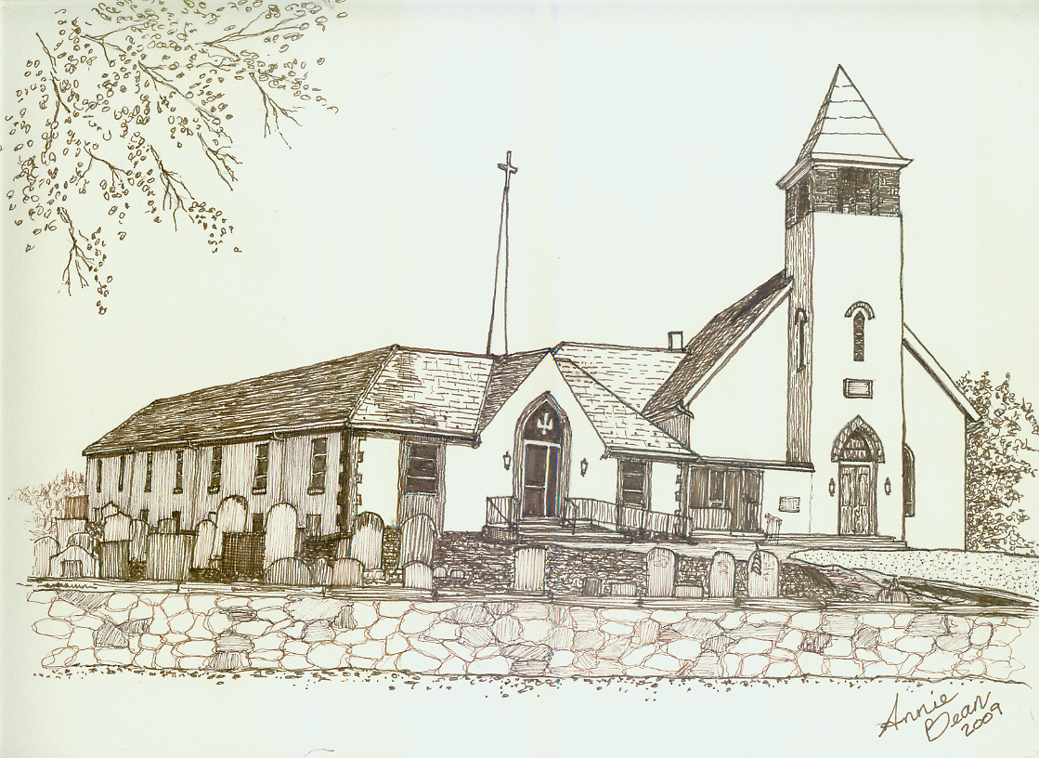

Fifth Sunday after Epiphany
February 9, 2020 10 a.m.
Welcome
We are glad you’re here to worship with us today.
This program has been especially designed
to enable you to participate fully in our Service.
May this be for you a time of refreshment and renewal.

ANNOUNCEMENTS

PRELUDE Be Thou My Vision arr. Hayes
Please use this time for quiet meditation before worship.
During the Service, the people will make the responses in the bold print.

CALL TO WORSHIP
All who are able may stand as we open our worship.
Let the Mystery of God draw us in:
Beautiful, Just, Merciful!

Let the Wisdom of God surprise us:
Vulnerable, Powerful, Searching!

Let the Glory of God shine through our work:
Salty, Bright and Good!

In the Mystery, the Wisdom, the Glory of God
Let us worship!

HYMN 655 Come Away from Rush and Hurry BEACH SPRING
After the hymn, please be seated.

INVOCATION
Wonderful God,
we gather today to celebrate your presence
in the lives of faithful people.
Send your Spirit to meet us here and guide us into your depths
that we may begin to glimpse your grace.
What eye has not seen, nor ear heard,
nor the human heart conceived--
all you have prepared for those who love you.

We extend this prayer in the name of Jesus,
His Mystery, His Wisdom, His Glory.

PRAYER OF CONFESSION KYRIE Isaiah reminds us that our prayer,
fasting and pious ritual,
must be lived out in compassion and justice.
When we forget the fast you desire—
to do justice, and stand up for the powerless:
Lord, have mercy upon us.
Sing: Lord, have mercy upon us.

When we forget the prayer you love—
to show compassion, and care for those in need:
Christ, have mercy upon us.
Sing: Christ, have mercy upon us.

When we abandon the rituals you require—
to create relationships of righteousness and peace
that we together can build up:
Lord, have mercy upon us.
Sing: Lord, have mercy upon us.

ASSURANCE OF PARDON
Friends, the love of God revealed in Jesus forgives us,
heals us and sets us free to rebuild,
restore, and raise up foundations for new generations.
With thanksgiving, let us offer one another a sign of peace.

GLORIA PATRI GLORIA PATRI
Glory be to the Father, and to the Son, and to the Holy Ghost;
as it was in the beginning, is now, and ever shall be,
world without end. Amen. Amen.

PASSING THE PEACE
The Peace of Our Lord Jesus Christ be with you.
And also with you.
Let us exchange with one another a sign of Christ’s peace, and then be seated.

ANTHEM Salt and Light*
Worship Ensemble

PRAYER OF THE DAY

A READING FROM THE LETTERS 1 Corinthians 2:1-12
Pew Bibles, Page 1773

A READING FROM PSALM 112:1-9
Praise the Lord.
Blessed are those who fear the Lord,
who find great delight in his commands.
Their children will be mighty in the land;
the generation of the upright will be blessed.

Wealth and riches are in their houses,
and their righteousness endures forever.
Even in darkness light dawns for the upright,
for those who are gracious and compassionate
and righteous.

Good will come to those who are generous and lend freely,
who conduct their affairs with justice.
Surely the righteous will never be shaken;
they will be remembered forever.
They will have no fear of bad news;
their hearts are steadfast, trusting in the Lord.
Their hearts are secure, they will have no fear;
in the end they will look in triumph on their foes.

They have freely scattered their gifts to the poor,
their righteousness endures forever;
their horn will be lifted high in honor.

ANTHEM Go, Light Your World arr. Allen
Chancel Choir

A WORD FOR ALL AGES
All children may come forward at this time to gather with Pastor Mark.
Those through Grade 6 will then be dismissed to Worship Play.

GOSPEL READING Matthew 5:13-20

SERMON We Are the Light Rev. Mark L. Stryjak

HYMN 502 Be Thou My Vision SLANE
After the hymn, please be seated.

GIVING AND RECEIVING OF TITHES AND OFFERINGS
Kindly hand your prayer request cards to the ushers.
Christ calls us to let our lives and our work—salty, bright, and good—
give witness to the reign of God in our midst. Let us generously offer our gifts of time, talent and treasure, that the glory of God may be recognized and celebrated in our world.

OFFERTORY Holy Is the Lord arr. Larson

PRESENTATION
All may stand as the offering is presented
and remain standing for the hymns and prayer that follows.
HYMN 34 OLD HUNDREDTH
Praise God from whom all blessings flow;
Praise Him all creatures here below;
Praise Him above, ye heavenly host;
Praise Father, Son, and Holy Ghost. Amen.

PRAYER OF DEDICATION
O God, we pray that these gifts and offering today
reach all those in need.
May our hearts be filled with joy and happiness
to extend your love to many.
In Jesus’ name we pray. Amen.

PRAYER HYMN 493 Cares Chorus
After the hymn, please be seated.

PRAYERS OF THE PEOPLE

HYMN 557 Pass It On
All who are able may stand.

BENEDICTION AND CHIMES
Let the Mystery of God send us into the world:
Beautiful, Just, Merciful!

Let the Wisdom of God surprise us in the world:
Vulnerable, Powerful, Searching!

Let the Glory of God shine through our work in the world:
Salty, Bright and Good!

In the Mystery, the Wisdom, the Glory of God
Let us rejoice!

POSTLUDE This Little Light of Mine arr. Hayes

As this service comes to an end, our service now begins!
Peace be with all of you!

*“Salt and Light” words and music by Lauren Ashley Daigle, Paul Mabury, Leslie Jordan | ©2014 CentricSongs | CCLI No. 11299289

Response to God's Love – February 2, 2020
Weekly Goal: $3,816
Contributions without endowment support: $2,090.50
Contributions with endowment support: $2,859.50
Attendance: 55 in church 5 in the Nursery



Brownback’s United Church of Christ
640 Ridge Road
Spring City, Pennsylvania 19475
Telephone 610.495.6788
Pastor Stryjak: mark.stryjak@comcast.net or 484-938-7397
Church Email: brownbacksucc@comcast.net
On the Internet at www.brownbackschurch.org

Ministers to the World The Congregation
Pastor and Teacher Rev. Mark L. Stryjak
Consistory President Barry Vining
Consistory Secretary Lara Faust
Parish Administrator Kris Houck
Choir Director Penny Sallade
Organist Patricia Kandler
Financial Secretary Anne Behe
Current Treasurer Holly Vining
Benevolence Treasurer Kaitlin Iezzi
Major Improvement Treasurer Calvin Idler
Endowment Board Chair John Stone
Christian Education Chair Kaitlin Iezzi
Sexton Larry Simmers
Cemetery Superintendent Greg Siwik
Pastor Emeritus Rev. Frank L. Lamson
Pastor Emeritus Rev. Dr. Eugene Grau

