News & Views

Brownback’s United Church of Christ March 2020

Spring City, Pennsylvania

# Fat Tuesday Pancake Dinner

“Mardi Gras” is French for Fat Tuesday. The holiday is also referred to as “Shrove Tuesday” (from an Old English word meaning to confess) or Pancake Day.

It is traditional in many societies to eat pancakes or other foods made with the butter, eggs, and fat that would be given up during the Lenten season. Similar foods are fasnachts and pączkis. The specific custom of British Christians eating pancakes on Shrove Tuesday (or Fat Tuesday) dates to the 16th century.

We at Brownback’s will join together on Tuesday, **February 25** at 6:00 PM to enjoy our annual Fat Tuesday Pancake Dinner. Come, enjoy!



## Calendar of Events

| Date | Time | Event |
| --- | --- | --- |
| March | | |
| 4 | 7:00 PM | Lent Service – St. Matthew’s UCC |
| 8 | 10:00 AM | Wesley Freeman baptism |
| 11 | 7:00 PM | Lent Service – Bethel UMC |
| 12 | Noon | Young at Heart |
| 15 |  | International Sunday |
| 18 | 7:00 PM | Lent Service – Parker Ford Baptist |
| 22 | 11:00 AM  3:00 PM | Pajama Sunday  Family Time  Winter Game Night/Dinner |
| 25 | 7:00 PM | Lent Service –St. Vincent UCC |

## Recurring Events

### Sunday Worship:

8:45 AM – Adult Sunday School

10:00 AM –Worship Service, Worship Time for Children, Kids JAM

### Faith Formation:

Women’s Bible Study – 10:00 AM, Tuesday

Men’s Breakfast – 8:30 AM, 2nd Monday

### Music:

Chancel Choir Rehearsal – 9:15 AM, Sunday

Good News Singers Rehearsal – 9:30 AM, 2nd Sunday

Worship Ensemble Rehearsal – 5:30 PM, Wednesday

Chancel Handbells – 6:45 PM, Wednesday

### Fellowship:

Fitness Classes – Monday/Wednesday at 8:45 AM

Young at Heart – Noon, 2nd Thursday

## Pastor’s Ponderings

As I write this article, the sun is shining and the temperature is hovering around 50 plus degrees, so I hope Spring is around the corner! I guess it is a case of Spring Fever but I am excited for it to begin! Anyway, we have many things going on or getting ready to occur here at Brownback’s.

We recently had our Christian Education meeting, and many things are moving along, including scheduling a Youth Sunday service. The detailed planning has yet to occur, but I am interested to see the creativity that will surface as we prepare and talk through the parts of the service.

Also, if any of you have a passion for helping to build up our youth programs, please contact me as I am excited to see this take off for the youth. There is a sense of urgency as there is a small window of opportunity to be involved and attend events, such as the National Youth Event, which is being held at Purdue University in late July this year. I am happy to report that we have some interest!

We will need chaperones so please consider July 22-25 to help facilitate seeing something very special take place. You can check out the specifics online by searching for National Youth Event 2020 UCC. It is a site to behold.

As we gear up for Spring and Summer, we have asked a few churches to join us for VBS this year. We are actively trying to pull resources so that we can continue to offer this special time for the children with plenty of volunteers to assist. If you have some time to offer, this is a wonderful thing.

I conclude this article by highlighting our upcoming Lenten services. We will host Ash Wednesday service here at 7:00 PM. The schedule for the remaining Wednesdays is posted throughout the church and found later in this newsletter. You are invited to join the East Coventry Community of Churches each Wednesday at 7:00 PM, followed by a time of fellowship afterwards.

My hope for all of us this Lenten season is to be able to see the pieces of our lives that hold us back from a completely full relationship with God and neighbor. As this journey unfolds for six weeks, may prayer, along with other disciplines of faithful living, fill each of our days!

Sincerely,

*Pastor Mark*

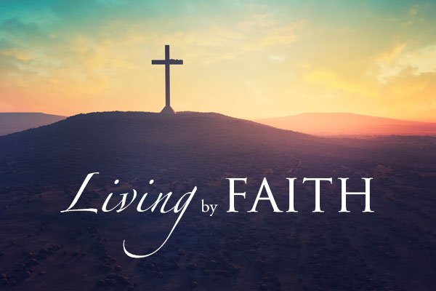

## National Youth Event

Every four years the United Church of Christ sponsors a National Youth Event. This summer the event will be held at Purdue University in West Lafayette Indiana from **July 22-25**. This four-day event is celebrated as the largest denominational gathering. Often bringing in 4,000 participants, this time together is focuses on faith, leadership, service, and social justice to empower our youth.

Kids grade 6-12 are encouraged to attend.

The Brownback’s UCC Missions Committee will help with some of the expense, and we will have fundraisers to help cover the cost ($375) per person.

This event is truly inspirational. Brownback’s has been sending youth to this event for decades. Several attendees have said what an incredible event it is and how special it was to celebrate being a Christian with so many of their peers throughout the country.

Please consider sending your child or children if they meet the age requirements. They will not be disappointed. Contact Pastor Mark or Chadd Bauer if you have any questions.

### Testimonial from Maddie Stone

When I was a member of the Brownback’s Youth Group, I had the opportunity to attend the National Youth Event in the summer of 2008 at the University of Tennessee. It was quite an adventure. We took a bus with a few other UCC churches in the area down to Knoxville. When we started our trip, I only knew our group from Brownback’s. But by the end, I formed friendships that will last a lifetime.

Those few days in Knoxville were full of friends, fellowship, and fun! They had workshops for everyone, ranging from ultimate Frisbee to the role of religion in Harry Potter. The group worships rocked the house, literally a new performance from Christian rock bands every night, and were followed by a race to the on-campus bowling alley where we continued to build on our friendships with other participants.

At the moment, I had no idea the larger impact trips like the National Youth Event would have on me. Events like NYE helped build the strong foundation I have with my faith today.

*--Maddie Stone*



## Lenten Services Planned

During the Lenten Season, we join with the East Coventry Union of Churches for Wednesday night services. All Services will begin at **7:00 PM** and are followed with fellowship and refreshments.

|  |  |
| --- | --- |
| **February 26** | **Ash Wednesday Brownback’s UCC 640 Ridge Rd, Spring City** |
| Teacher | Rev. Ron Hughes, St. Matthew’s UCC |
| **March 4** | **St. Matthew’s UCC 2350 Conestoga Rd, Chester Springs** |
| Teacher | Rev. Jacqueline Hines, Bethel UMC |
| **March 11** | **Bethel United Methodist Church 952 Bethel Church Rd, Spring City** |
| Teacher | Rev Susan Hanson, St. Vincent UCC |
| **March 18** | **Parkerford Baptist Church 92 Baptist Church Rd, Parkerford** |
| Teacher | Dave Willauer, Parker Ford Church |
| **March 25** | **St. VincentUCC 137 Ridge Rd, Phoenixville** |
| Teacher | Rev. Mark Stryjak, Brownback’s UCC |
| **April 1** | **St. Matthew’s UCC 2350 Conestoga Rd, Chester Springs** |
| Teacher | Rev. Robert Davalt II, Parkerford Baptist |



## Freeman Baptism

Join us on Sunday, **March 8** for the baptism of Wesley Freeman, son of Andrew and Paige Freeman, and grandson of Rick and Jeanette Francesco. Before the Freeman’s relocate to Portsmouth, VA, they wanted to baptize Wesley in Paige’s home church with her church family.

Light refreshments to follow in Fellowship Hall.

## International Sunday

On Sunday, **March 15**, we will celebrate International Sunday during our Fellowship hour after the Worship service. Do you have a favorite snack with an international flavor? Does your family have a recipe with international flair? Please bring in your favorite snacks from around the world on March 15 as we celebrate snacks from around the world during social hour.

We are counting on our congregation to wow their fellow members with exotic foods.

## Pajama Sunday

Join us for Pajama Sunday, on **March 22**! This is a day when you can roll out of bed and come to church in your favorite PJs to celebrate Spring!

## Family Time

On Sunday, **March 22** after Worship, parents will meet in the parlor for discussion while children join in the back of the Fellowship Hall for fun activities.

## Winter Game Night

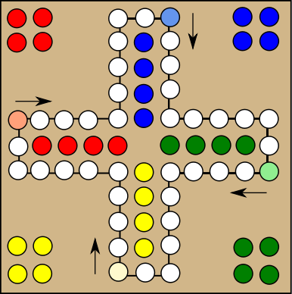The Fellowship Committee will be hosting a Winter Game Night on Sunday, **March 22** at 3:00 PM. There will be a variety of games provided, but feel free to bring a favorite of your own! Please let us know in advance if your game requires any equipment from us, like a TV or sound. We also ask that you bring some sort of snack to share, as we are sure to work up an appetite engaging in friendly competition!

## Fellowship Committee Needs You

Do you enjoy social opportunities at Brownback’s? The Fellowship Committee would like to add two additional members to their crew. They meet 2-3 times per year after church, and coordinate many of the social activities for the church. Contact Kaitlin Iezzi with interest or for more information.

## Men’s Breakfast

The men of the church are invited to breakfast at The Ridge Restaurant on **March 9** at 8:30 AM. Breakfast is BYOB – Bring Your Own Bible. See Pastor Mark for the lectionary.

## Young at Heart

What has heart placements, vases with red and pink hearts and roses, a big red Valentine candy box flanked with red candles, and a Valentine card at each place setting? That is the Fellowship Hall decorated by Bernie and Earl Brungess for February’s Young at Heart luncheon held on February 13th at Brownback’s.

Pastor Mark opened with prayer. Nancy Peiffer thanked all persons who help and contribute to making our Young at Heart function run smoothly. Fifty-seven persons partook of a menu consisting of baked ham, stewed tomatoes, macaroni and cheese, plus side dishes. Ice cream, cheese cake, and a variety of other delicious desserts graced the dessert table.

Brenda Thompson was awarded a Wawa gift card and a Valentine box of candy for having the winning envelope.

Nancy introduced David Reinwald–Pastor, Songwriter, Musician, and Humorist. Having all his equipment ready, he then picked up his guitar and started entertaining us with songs from the 50s and 60s. He interspersed his singing with humoristic dialogue and jokes. He sang a couple of Elvis Presley’s hits doing a good imitation of the King. We clapped to the beat of some oldies and joined David in singing a couple of Frankie Valli’s hit songs. When David closed the program with “Proud to be an American,” we all stood. He then joined us in our Friendship Circle as we sang “Blest Be the Tie That Binds.”

Young at Heart’s next luncheon will be held on **March 12** at Noon. Bob and Susie Lee will present the program, “It’s Washday.” They will share a collection of “washing tools” from the 1700s through the 1940s. Join us and find out how your great-grandmother washed her clothes way back when. I think we’ll come away with a new appreciation for the machine that does the job for us now. See you on Thursday, March 12th.  *– by Pat Diener*

## Daylight Saving Time

The main purpose of Daylight Saving Time (called “Summer Time” in many places in the world) is to make better use of daylight. We change our clocks during the summer months to move an hour of daylight from the morning to the evening. Various countries have different change dates.

A poll conducted by the U.S. Department of Transportation in 1976 of 2.7 million citizens showed that Americans liked Daylight Saving Time (DST) because there is more light in the evenings, enabling folks to do more things in the evenings. DST also trims the country’s electricity usage by a small but significant amount (about 1% per day). Some studies also show that DST decreases the number of traffic accidents. However, research indicates that walkers are three times as likely to be hit and killed by cars right after the switch in the Fall. So be careful on the road!

Remember to set your clocks ahead (“Spring forward”) on the evening of Saturday, **March 7** so that you don’t miss the Worship service!

## Canned Goods and Household Items

During Brownback’s January Food Collection, individuals from Brownback’s donated a total of over 350 lbs of items to the Spring City Food Pantry. These items included non-perishable food and cleaning/storage/health-related products.

Thanks to Chadd Bauer’s “Souper” Bowl Sunday challenge, where we voted for our favorite team by bringing in cans of soup, it really pushed us over the top! Thank you for your generation donations. Also, thanks to Bob Jacob and Pat Diener for delivering all 350 lbs of food donations to the pantry.

## Cemetery Reminders

Flowers can be placed in front of a headstone not to exceed 12” from the stone and squared front only. All holiday wreaths will be removed starting the week of **March 8th** in preparation for Easter. Any planters or metal stands will be placed on the side of the garage. Any items found to be unsafe or unauthorized will be removed.

## Flower Chart

The Flower Chart for 2020 is now available on the bulletin board in the lobby near the Sign-Up Center. Please consider sponsoring the purchase of flowers to decorate our sanctuary during Worship. Flowers cost $40 per week, with checks payable to “Brownback’s UCC”. Sign up for a week now! Spots fill quickly.

## News & Views Deadline

The deadline for the April issue of the *News & Views* newsletter is **March 19**. To include information in the newsletter, you can leave information in the *News & Views* mailbox in the church lobby or email information to Penny Sallade at pennysallade@yahoo.com.

## Paper and Plastic Grocery Bags

The Spring City Food Pantry is in critical need of paper and plastic grocery bags (particularly paper bags). Please consider donating your used bags at church to be delivered to the pantry. Boxes are labeled and located under the table at the back of Fellowship Hall.

The Spring City Pantry thanks you for the paper and plastic bags and egg cartons. They are needed all 52 weeks of the year!

## Easter Egg Hunt

Mark your calendars! The Easter Bunny will be hopping by Brownback’s UCC on **SUNDAY**, **April 5** after the Worship Service for the annual Easter Egg Hunt.

Children through Grade 6 are invited to hunt for eggs. Immediately following the hunt, join us inside for games, prizes, snacks, and fellowship.

This event is rain or shine. In the event of bad weather, the bunny hides eggs inside the church!



## Prayer Concerns

“And whatever you ask in prayer, you will receive, if you have faith.” – Matthew 21:22

For those who serve:

* Reed Bauer, 2nd year cadet at West Point, The United States Military Academy
* Nathaniel Cherubini, Chief Warrant Officer 3,   
  United States Marine Corp. Nephew of Rick and Jeanette Francesco
* Brock Fasnacht, nephew of Doug and Sue Kandler, Army National Guard
* Paige Juliette Freeman, Trooper First Class, Delaware State Police
* Andrea Shade, 4th year cadet at West Point, The United States Military Academy
* Thomas Shade, Captain in the Army based in South Carolina

**Members**: Rich Bauer, Joe Kandler, Sr., Pat Kandler, Bob Keeley, Sr., Thelma Nelson, Marie Painter.

**Friends of Brownback’s**: Eva Diener, Pat Gunther, Theresa Herd, Ali Hughes, Theresa Kistler, Jeanne Kurtz, Sean Mahoney, Fran McGinley, Tiffany Pfleger, Jim Raifsnider, Sue Stultz, Craig Warwood, and Bruce (a friend of Overholtzer family).

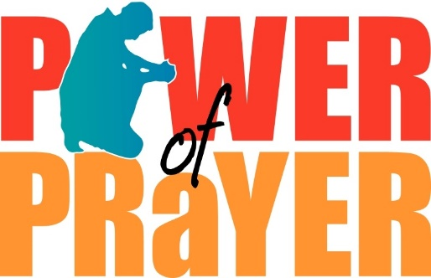

## March Birthdays



We rejoice with those of our church family who are celebrating birthdays in March.

3/1 David Nelson

Maddison Stone

3/7 Nicole Wiand

3/11 Reese Ruilova

3/12 Vickie Bradley

3/18 Elizabeth Sweitzer

3/20 Bill Faust

3/21 Morgan Stone

3/22 Carter Spiess

3/24 Riley Bauer

3/25 Lawrence Blair

Gunther Kull

3/26 Alexis Ford

3/29 Charlie Kullen

## March Anniversaries

We congratulate the following in our church family who are celebrating wedding anniversaries in March.

3/21 Barry and Cherie Copenhaver

## Our Church Leaders

Rev. Mark Stryak, Pastor and Teacher

Barry Vining, President

Mark Sweitzer, Vice President

Lara Faust, Secretary

Anne Behe, Financial Secretary

Holly Vining, Current Treasurer

Kaitlin Iezzi, Benevolence Treasurer

Calvin Idler, Major Improvements Treasurer

#### Elders

2020 Earl Brungess Barry Vining

2021 Randall Ruilova Mark Sweitzer

2022 Chadd Bauer Bob Keeley

#### Deacons

2020 Derrick Boaman Kaitlin Iezzi

2021 Calvin Idler Anne Behe

2022 Lara Faust Larry Potts

#### Cemetery Board

2020 Rick Francesco

2021 Brian Iezzi Greg Siwik

2022 Mike Houck Barry Vining

#### Endowment Board

2020 Mike Houck

2021 Bob Keeley Barry Vining

2022 Bill Moore Julie Radel

#### Our Church Staff

Kris Houck, Parish Administrator

Penny Sallade, Choir Director

Patricia Kandler, Organist

Larry Simmers, Sexton

Kaitlin Iezzi, Christian Education Chair

Greg Siwik, Cemetery Superintendent

Brownback United Church of Christ

640 Ridge Road

Spring City, Pennsylvania 19475

Address Service Requested