Welcome to Brownback’s

United Church of Christ

640 Ridge Road
Spring City, Pennsylvania

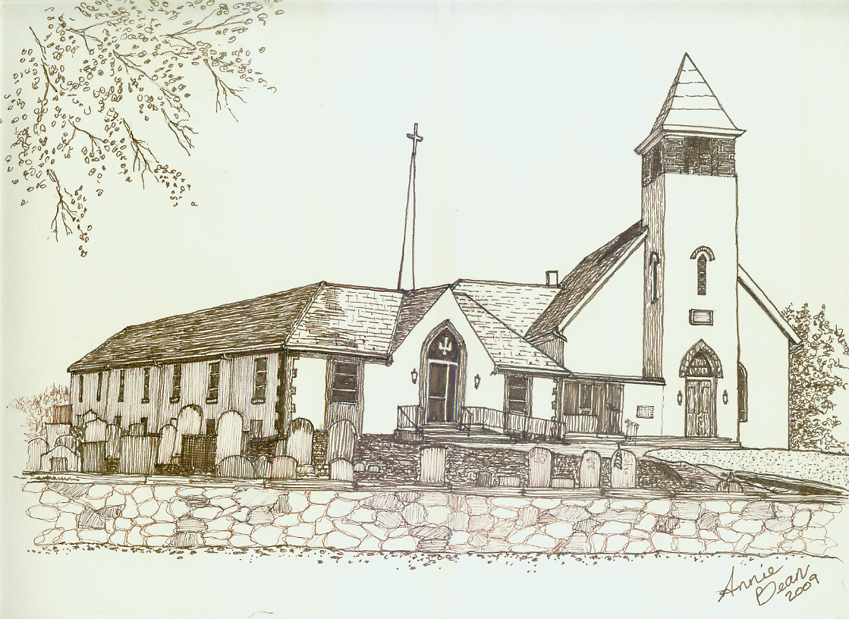

Pentecost 16
September 29, 2019 10 a.m.
Welcome
We are glad you’re here to worship with us today.

This program has been especially designed

to enable you to participate fully in our Service.

May this be for you a time of refreshment and renewal.

ANNOUNCEMENTS

PRELUDE Onward Christian Soldiers Sullivan
Please use this time for quiet meditation before worship.
During the Service, the people will make the responses in the bold print.

CALL TO WORSHIP based on Psalm 91:1-6, 14-16 and 1 Timothy 6:6-19
All who are able may stand as we open our worship.
Life that is really life,
comes from the One we trust.

Life that is really life,
comes from the Presence we call to.

Life that is really life,
comes from the Foundation of goodness and sharing.

Life that is really life,
comes to us now in this moment.

Let us take hold of Life that is really Life!

HYMN 48 Immortal, Invisible, God Only Wise ST. DENIO
After the hymn, please be seated.

INVOCATION
May we now join together this morning and pray our communal confession to our Still Speaking God.

PRAYER OF CONFESSION
Confessions can be so difficult God,
yet we value the importance of honesty,
integrity and commitment,
and that is why we stand before your Spirit here today.
As we live our lives and with the best of intentions,
not all our actions and words and thoughts go as planned. We are busy people with full calendars
and where patience and empathy may run a little thin,
we may miss seeing the person in need
that is right outside our doorstep or the closest to us.
In our commitment to our faith and to you,
we confess both in spirit and in word today
where we have mis-stepped and also to be aware of those moments that we may not have noticed.
We ask in prayer this day that our minds and spirits
will always be open to being the person
you created us to be.

In Christ’s name, we pray.

ASSURANCE OF PARDON
Children of God,
we believe that through confessing our sins,
both publicly and privately,
Christ assures us that we are forgiven.
May we live into that new life,
that new way of being, today!
Thanks be to God.

GLORIA PATRI GLORIA PATRI
Glory be to the Father, and to the Son, and to the Holy Ghost;
as it was in the beginning, is now, and ever shall be,
world without end. Amen. Amen.
THE PEACE
The Peace of Our Lord Jesus Christ be with you.
And also with you.
Let us exchange with one another a sign of Christ’s peace, and then be seated.

ANTHEM God of Wonders*
Worship Ensemble

PRAYER OF THE DAY

A READING FROM THE PROPHETS Amos 6:1,4-7
Pew Bibles, Page 1427

A READING FROM PSALM 146
Praise the Lord.
Praise the Lord, my soul.
I will praise the Lord all my life;
I will sing praise to my God as long as I live.

Do not put your trust in princes,
in human beings, who cannot save.
When their spirit departs, they return to the ground;
on that very day their plans come to nothing.

Blessed are those whose help is the God of Jacob,
whose hope is in the Lord their God.
He is the Maker of heaven and earth,
the sea, and everything in them—
he remains faithful forever.

He upholds the cause of the oppressed
and gives food to the hungry.
The Lord sets prisoners free,
the Lord gives sight to the blind,
the Lord lifts up those who are bowed down,
the Lord loves the righteous.
The Lord watches over the foreigner
and sustains the fatherless and the widow,
but he frustrates the ways of the wicked.
The Lord reigns forever,
your God, O Zion, for all generations.

Praise the Lord.

ANTHEM In This Very Room arr. Harris
Chancel Choir

A WORD FOR ALL AGES
All children may come forward at this time to gather with Pastor Mark.
Those through Grade 6 will then be dismissed to Worship Play.

GOSPEL READING Luke 16:19-31
SERMON Where is Our Empathy? Rev. Mark L. Stryjak

HYMN 232 Let All Mortal Flesh Keep Silence PICARDY
After the hymn, please be seated.

GIVING AND RECEIVING OF TITHES AND OFFERINGS
Kindly hand your prayer request cards to the ushers.
In thanksgiving and appreciation for our shared life together, let us give for the continual work of this church and the wider community.

OFFERTORY Allegretto Handel

PRESENTATION
All may stand as the offering is presented
and remain standing for the hymns and prayer that follows.

HYMN 34 OLD HUNDREDTH
Praise God from whom all blessings flow;
Praise Him all creatures here below;
Praise Him above, ye heavenly host;
Praise Father, Son, and Holy Ghost. Amen.

PRAYER OF DEDICATION
God of eternity,
we have shared a piece of what we have
with your church.
We pray to you that our offerings are plentiful in your sight
and may they stretch as wide as the ocean
to where they are needed,
today and always and in Christ’s name. Amen.

PRAYER HYMN 483 Take Time to Be Holy HOLINESS
We will sing verse 1 only.
After the hymn, please be seated.

PRAYERS OF THE PEOPLE

LORD’S PRAYER
Our Father,
who art in heaven,
hallowed be thy name.
Thy kingdom come.
Thy will be done,
on earth as it is in heaven.
Give us this day our daily bread.
And forgive us our debts,
as we forgive our debtors.
And lead us not into temptation,
but deliver us from evil:
for thine is the kingdom,
and the power, and the glory forever. Amen.
APOSTLE’S CREED
I believe in God the Father Almighty,
maker of heaven and earth;
and in Jesus Christ his only Son our Lord:
who was conceived by the Holy Spirit,
born of the Virgin Mary,
suffered under Pontius Pilate,
was crucified, died, and was buried.
On the third day he rose from the dead;
he ascended into heaven,
and sits at the right hand of God the Father Almighty;
from then he shall come to judge
the quick and the dead.
I believe in the Holy Spirit,
the holy catholic church,
the communion of saints,
the forgiveness of sins
and the resurrection of the body,
and the life everlasting. Amen.

HYMN 138 Holy God, We Praise Your Name GROSSER GOTT
All who are able may stand.

BENEDICTION AND CHIMES
May our eyes be always lifted to see the horizon before us,
the needs around us and the ongoing comfort
of your Spirit God that surrounds us today.
Go now with the peace of Christ. Amen.

POSTLUDE March Schumann

As this service comes to an end, our service now begins!
Peace be with all of you!
*Words and Music by Marc Byrd and Steve Hindalong | ©2000 Never Say Never Songs | CCLI No. 11299289

Response to God's Love – September 22, 2019
Weekly Goal: $3,893
Contributions without endowment support: $2,149.00
Contributions with endowment support: $2,995.00
Attendance: 55 in church 5 in the Nursery



Brownback’s United Church of Christ
640 Ridge Road
Spring City, Pennsylvania 19475
Telephone 610.495.6788
Pastor Mark’s Office Hours: Monday, Tuesday 9 a.m. – 12:30 p.m.
Wednesday 10 a.m. – 1 p.m.
Church Office Hours: Tuesday, Wednesday 8:30 a.m. – 2 p.m.
Thursday 8:30 a.m. – 1:30 p.m.
Pastor Stryjak: mark.stryjak@comcast.net or 484-938-7397
Church Email: brownbacksucc@comcast.net
On the Internet at www.brownbackschurch.org

Ministers to the World The Congregation
Pastor and Teacher Rev. Mark L. Stryjak
Consistory President Barry Vining
Consistory Secretary Amy Stone
Parish Administrator Kris Houck
Choir Director Penny Sallade
Organist Patricia Kandler
Financial Secretary Anne Behe
Current Treasurer Holly Vining
Benevolence Treasurer Kaitlin Iezzi
Major Improvement Treasurer Calvin Idler
Endowment Board Chair John Stone
Christian Education Chair Kaitlin Iezzi
Sexton Larry Simmers
Cemetery Superintendent Greg Siwik
Pastor Emeritus Rev. Frank L. Lamson
Pastor Emeritus Rev. Dr. Eugene Grau

