**Welcome to Brownback’s**

**United Church of Christ**

640 Ridge Road

Spring City, Pennsylvania

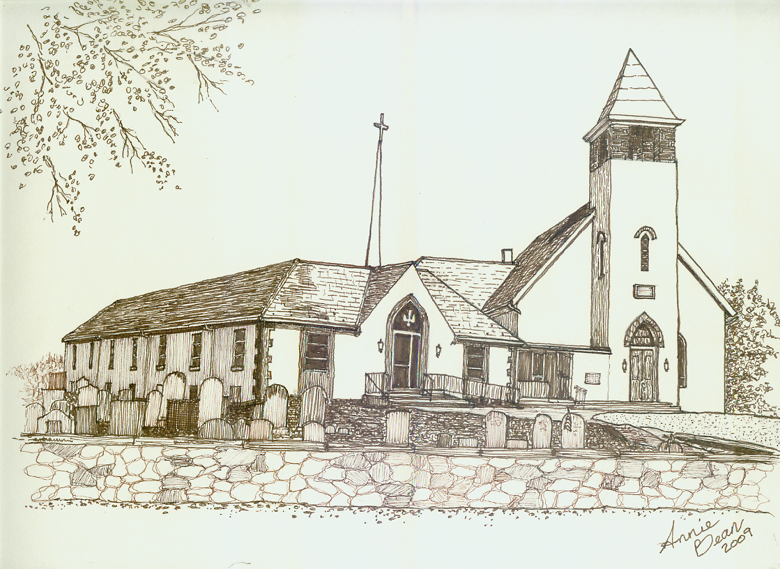

**Twentieth Sunday after Pentecost**

**October 18, 2020 10 a.m.**

**Welcome**

*We are glad you’re here to worship with us today.*

*May this be for you a time of refreshment and renewal.*

ANNOUNCEMENTS

PRELUDE The Church’s One Foundation arr. Larson

*Please use this time for quiet meditation before worship.*

*During the Service, the people will make the responses in the* ***bold*** *print.*

CALL TO WORSHIP *

O sing to the LORD a new song;

sing to the LORD, all the earth.

**Sing to the LORD, bless God’s name;**

**tell of God’s salvation from day to day.**

Declare God’s glory among the nations,

God’s marvelous works among all the peoples.

**For great is the LORD, and greatly to be praised;**

**God is to be revered above all**.

HYMN 87 Come, Christians Join to Sing MADRID

INVOCATION

PRAYER OF CONFESSION*AND ASSURANCE OF PARDON

THE VIRTUAL PEACE OF CHRIST  
 The Peace of Our Lord Jesus Christ be with you.

**And also with you.**

A READING FROM THE LAW Exodus 33:12-23

A READING FROM EPISTLES 1 Thessalonians 1:1-10

PA WORD FOR ALL AGES

*A virtual time to gather with Pastor Mark.*

SPECIAL MUSIC We Bow Down arr. Larson

GOSPEL READING Matthew 22:15-22

SERMON “A Living Message” Rev. Mark L. Stryjak

HYMN 51 How Great Thou Art

GIVING AND RECEIVING OF TITHES AND OFFERINGS

PRAYER HYMN What A Friend We Have in Jesus CONVERSE

(1st verse only)

JOYS AND CONCERNS

*Out of an abundance of caution, only first names will be used during our livestreaming*.

PRAYERS OF THE PEOPLE

LORD’S PRAYER

**Our Father, who art in heaven, hallowed be thy name.**

**Thy kingdom come. Thy will be done, on earth as it is in heaven.**

**Give us this day our daily bread.**

**And forgive us our debts, as we forgive our debtors.**

**And lead us not into temptation, but deliver us from evil:**

**for thine is the kingdom, and the power, and the glory forever. Amen.**

BENEDICTION AND CHIMES

POSTLUDE I Sing the Mighty Power of God arr. Larson

*As this service comes to an end, our service now begins!*

*Peace be with all of you!*

**\*** Portions of liturgy created/adapted by Rev. Mindi Welton-Mitchell, rev-o-lution.org

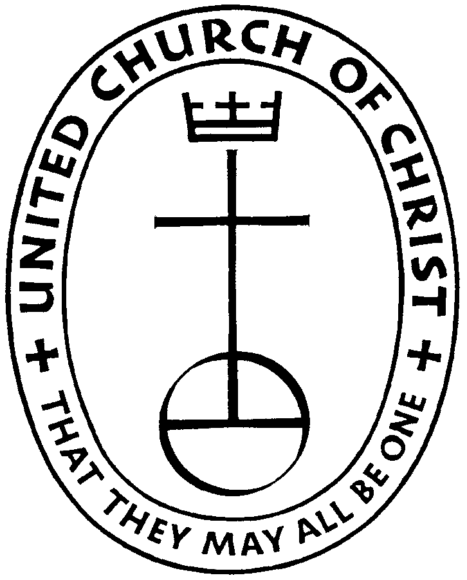

**Brownback’s United Church of Christ**

640 Ridge Road

Spring City, Pennsylvania 19475

Telephone 610.495.6788

Pastor Mark’s Office Hours: Monday, Tuesday 9 a.m. – 12:30 p.m.

Wednesday 10 a.m. – 1 p.m.

Church Office Hours by Phone: Tuesday, Wednesday 8:30 a.m. – 2 p.m.

Thursday 8:30 a.m. – 1:30 p.m.

Pastor Stryjak: [mark.stryjak@comcast.net](mailto:mark.stryjak@comcast.net) or 484-938-7397

Church Email: [brownbacksucc@comcast.net](mailto:brownbacksucc@comcast.net)

On the Internet at [www.brownbackschurch.org](http://www.brownbackschurch.org/)

Ministers to the World The Congregation

Pastor and Teacher Rev. Mark L. Stryjak

Consistory President Barry Vining

Consistory Secretary Lara Faust

Parish Administrator Kaitlin Iezzi

Choir Director Penny Sallade

Organist Patricia Kandler

Financial Secretary Anne Behe

Current Treasurer Holly Vining

Benevolence Treasurer Kaitlin Iezzi

Major Improvement Treasurer Calvin Idler

Endowment Board Chair Bill Moore

Christian Education Chair Kaitlin Iezzi

Sexton Larry Simmers

Cemetery Superintendent Greg Siwik

Pastor Emeritus Rev. Frank L. Lamson

Pastor Emeritus Rev. Dr. Eugene Grau