Welcome to Brownback’s

United Church of Christ

640 Ridge Road
Spring City, Pennsylvania

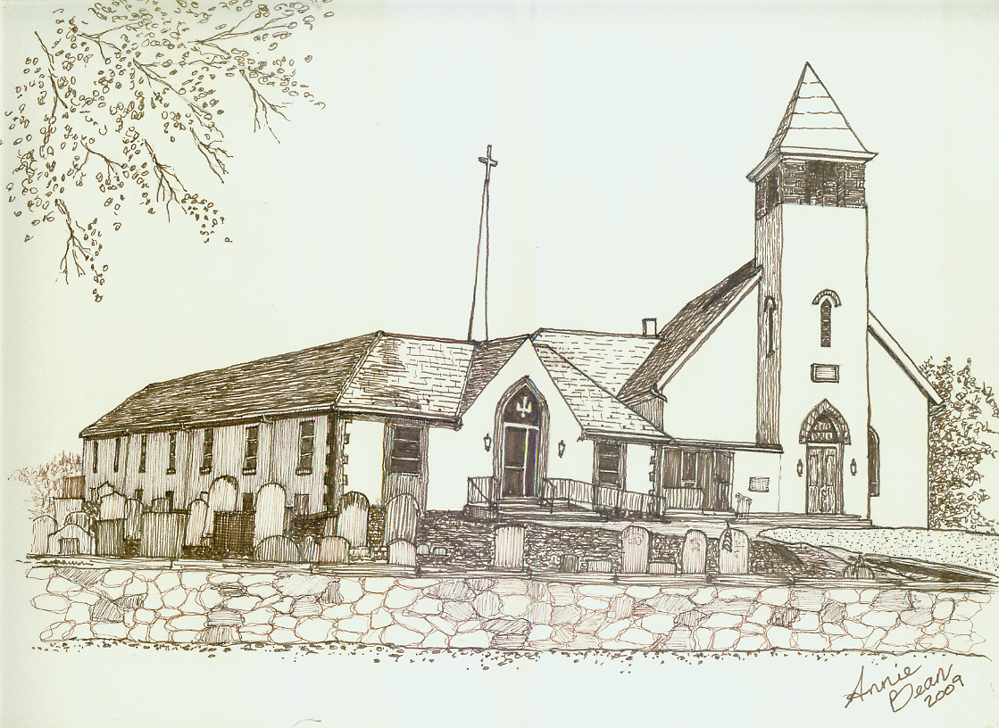

Pentecost 17
October 6, 2019 10 a.m.
Welcome
We are glad you’re here to worship with us today.

This program has been especially designed

to enable you to participate fully in our Service.

May this be for you a time of refreshment and renewal.

ANNOUNCEMENTS

PRELUDE The Soul Set Free Paxton
Please use this time for quiet meditation before worship.
During the Service, the people will make the responses in the bold print.

CALL TO WORSHIP
All who are able may stand as we open our worship.
We gather together as those with little faith
and those with much;
but we all gather to have our faith increased.

We gather together as those who serve
and those who are served;
but none of us deserve special praise.

We are all God’s beloved.
Let us serve and praise the Creator of love.

HYMN 35 Morning Has Broken BUNESSAN
After the hymn, please be seated.

INVOCATION
As we gather as one body of Christ
and in our growing community,
may we all join in praying our communal confession.

PRAYER OF CONFESSION
God who is Love,
we confess that we have misused this precious word.
We’ve used it insincerely.
We’ve used is as a weapon to abuse others.
We’ve shared it,
and then broken the foundation of trust
that love is built upon.
Forgive us,
Loving One,
and call us into repentance.
Help us to remember
that we have entered into a covenant with You,
and You have commanded us to love one another.
May our love grow to be genuine,
to be merciful and forgiving.
May our love call us to seek justice for our neighbors.
May the love You have given us help us to grow
into the people You have called us to be.
In the name of Christ,
who is Love,
we pray. Amen.

ASSURANCE OF PARDON
God is the one who showers us with waterfalls of grace,
no matter what we have done
or where we are on life’s journey.
God shares with us a purpose and calling so wonderful,
that the world may know grace as revealed in Christ.
May we all know that we are forgiven
and are able to live a new life in Christ today. Thanks be to God.

GLORIA PATRI GLORIA PATRI
Glory be to the Father, and to the Son, and to the Holy Ghost;
as it was in the beginning, is now, and ever shall be,
world without end. Amen. Amen.

THE PEACE
The Peace of Our Lord Jesus Christ be with you.
And also with you.
Let us exchange with one another a sign of Christ’s peace, and then be seated.

PRAYER OF THE DAY
. . . Amen!

A READING FROM THE PROPHETS Habakkuk 1:1-4; 2:1-4
Pew Bibles, Page 1456

A READING FROM PSALM 37:1-9
Do not fret because of those who are evil
or be envious of those who do wrong;
for like the grass they will soon wither,
like green plants they will soon die away.
Trust in the Lord and do good;
dwell in the land and enjoy safe pasture.

Take delight in the Lord,
and he will give you the desires of your heart.
Commit your way to the Lord;
trust in him and he will do this:
He will make your righteous reward shine like the dawn,
your vindication like the noonday sun.

Be still before the Lord
and wait patiently for him;
do not fret when people succeed in their ways,
when they carry out their wicked schemes.
Refrain from anger and turn from wrath;
do not fret—it leads only to evil.

For those who are evil will be destroyed,
but those who hope in the Lord will inherit the land.

ANTHEM We Are the Body of Christ*
Chancel Choir

A WORD FOR ALL AGES
All children may come forward at this time to gather with Pastor Mark.
Those through Grade 6 will then be dismissed to Worship Play.

EPISTLE READING 2 Timothy 1:1-14
GOSPEL READING Luke 17:5-10

SERMON Increase Our Faith Rev. Mark L. Stryjak

SACRAMENT OF HOLY BAPTISM Preston Scott Wysocki

HYMN 51 How Great Thou Art
All who are able may stand.
After the hymn, please be seated.

GIVING AND RECEIVING OF TITHES AND OFFERINGS
May we come together now and offer out of our abundance for the love that God, our creator, has shown to us.

OFFERTORY Chapel Prayer Simone

PRESENTATION
All may stand as the offering is presented
and remain standing for the hymns and prayer that follows.

HYMN 34 OLD HUNDREDTH
Praise God from whom all blessings flow;
Praise Him all creatures here below;
Praise Him above, ye heavenly host;
Praise Father, Son, and Holy Ghost. Amen.

PRAYER OF DEDICATION
We are blessed.
We have witnessed the faith of others.
We have felt their courage
and known their spirits of love and power.
Through this tangible action of giving to Christ’s ministries, through the belief that one passes
into the light of Christ through Baptism,
may these offerings today,
our time and our talents we offer to you God,
be forever pleasing in your sight. Amen.

PRAYER HYMN 483 Take Time to Be Holy HOLINESS
We will sing verse 1 only.
After the hymn, please be seated.

PRAYERS OF THE PEOPLE

HOLY COMMUNION
Please refer to the laminated insert in the pews.
We invite all who follow Christ to join us in this Holy Communion.
It is our custom to use grape juice in our celebration.

HYMN 692 Eat This Bread and Never Hunger MODESTO

BENEDICTION AND CHIMES
As we leave the beauty and safety of this sanctuary,
may we take God’s promises with us this day
as we all recall how we received our faith
and most importantly,
how we will continue to pass it on!
May God’s blessings touch all of us this day
and forevermore. Amen.

POSTLUDE God the Omnipotent Thygerson

As this service comes to an end, our service now begins!
Peace be with all of you!

*“We Are the Body of Christ” words and music by Scott Wesley Brown and David Hampton | ©1997 New Spring | CCLI No. 11299289

Response to God's Love – September 30, 2019
Weekly Goal: $3,893
Contributions without endowment support: $1,535.00
Contributions with endowment support: $2,381.00
Attendance: 66 in church 4 in the Nursery

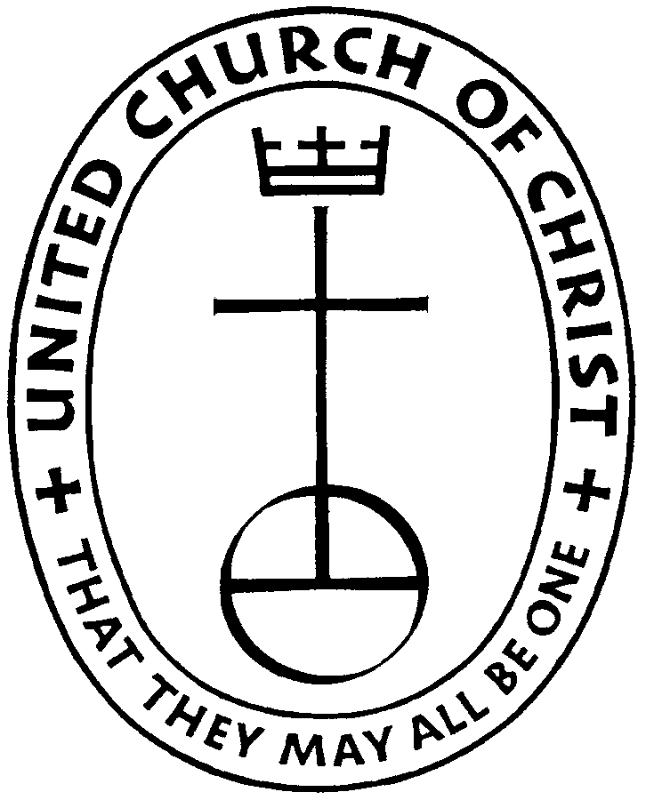

Brownback’s United Church of Christ
640 Ridge Road
Spring City, Pennsylvania 19475
Telephone 610.495.6788
Pastor Mark’s Office Hours: Monday, Tuesday 9 a.m. – 12:30 p.m.
Wednesday 10 a.m. – 1 p.m.
Church Office Hours: Tuesday, Wednesday 8:30 a.m. – 2 p.m.
Thursday 8:30 a.m. – 1:30 p.m.
Pastor Stryjak: mark.stryjak@comcast.net or 484-938-7397
Church Email: brownbacksucc@comcast.net
On the Internet at www.brownbackschurch.org

Ministers to the World The Congregation
Pastor and Teacher Rev. Mark L. Stryjak
Consistory President Barry Vining
Consistory Secretary Amy Stone
Parish Administrator Kris Houck
Choir Director Penny Sallade
Organist Patricia Kandler
Financial Secretary Anne Behe
Current Treasurer Holly Vining
Benevolence Treasurer Kaitlin Iezzi
Major Improvement Treasurer Calvin Idler
Endowment Board Chair John Stone
Christian Education Chair Kaitlin Iezzi
Sexton Larry Simmers
Cemetery Superintendent Greg Siwik
Pastor Emeritus Rev. Frank L. Lamson
Pastor Emeritus Rev. Dr. Eugene Grau

