Welcome to Brownback’s

United Church of Christ

640 Ridge Road
Spring City, Pennsylvania

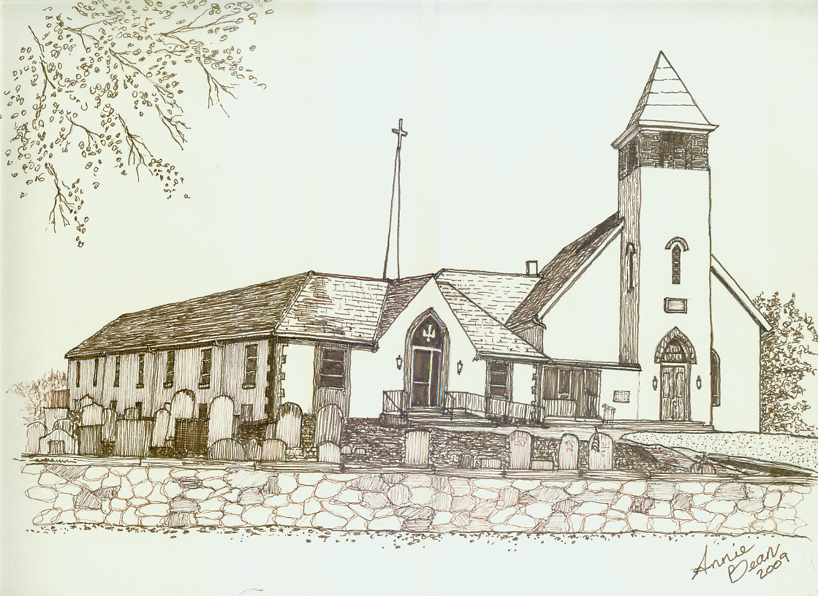

Pentecost 13 Rally Day
September 8, 2019 10 a.m.
Welcome
We are glad you’re here to worship with us today.

This program has been especially designed

to enable you to participate fully in our Service.

May this be for you a time of refreshment and renewal.

ANNOUNCEMENTS

PRELUDE Adagio Molto Guilmant
Please use this time for quiet meditation before worship.
During the Service, the people will make the responses in the bold print.

CALL TO WORSHIP
All who are able may stand as we open our worship.
Take the offbeat path,
the lesser-worn trail;
seek the deeper wisdom of God,
and you will find your way.

Meet the people on the margins,
help those suffering from oppression;
follow Jesus,
and learn how to love your neighbor and yourself.

Seek peace by pursuing justice,
practicing kindness and mercy;
know the Spirit is working all things in you
for the goodness of God.

Come, turn from the ways of the world,
and into God’s ways;
the journey may not be easy,
but we are in this together.
Come, worship God,
follow Jesus, and trust the Holy Sprit. Amen.
HYMN 350 The Summons KELVINGROVE
After the hymn, please be seated.

CALL TO CONFESSION
In penitence and in faith,
let us confess our sin to the One
who waits to pour out mercy upon us.

PRAYER OF CONFESSION
God of justice and mercy,
we confess that our ways are not always your ways.
The easier path to walk in this life is enticing
but we know that it avoids all your people,
whom we can then turn a blind eye to
the problems that they face.

We choose the well-worn trail for simple acts of kindness
rather than the radical way of mercy,
empathy, and compassion.
Humanity chooses the hall of mirrors that shows us
what we want to see, more of people like ourselves,
rather than the long hall that requires
the work of justice, leading toward restoration.

Forgive us.
Guide us to double-back and relearn your ways of justice, mercy, and love.
Though they are hard, they are worth it,
and they are what you intended
before humanity made the world
with the systems of sin we live in.
Help us to crack the hall of mirrors,
to break away from the well-worn trail
and take the more difficult way of love
that calls us to meet the needs of others.
In the name of Christ Jesus,
who gave up the world’s ease and went to the cross,
we pray. Amen.

ASSURANCE OF PARDON Psalm 1
Beloved, your sins are forgiven.
Therefore, be at peace to follow the good road,
for the Lord watches over the way of the righteous.

GLORIA PATRI GLORIA PATRI
Glory be to the Father, and to the Son, and to the Holy Ghost;
as it was in the beginning, is now, and ever shall be,
world without end. Amen. Amen.

THE PEACE
The Peace of Our Lord Jesus Christ be with you.
And also with you.
Let us exchange with one another a sign of Christ’s peace, and then be seated.

ANTHEM The Way*
Worship Ensemble

PRAYER OF THE DAY

A READING FROM THE EPISTLES Philemon 1:1-21
Pew Bibles, Page 1860

A READING FROM PSALM 1
Blessed is the one
who does not walk in step with the wicked
or stand in the way that sinners take
or sit in the company of mockers,
but whose delight is in the law of the Lord,
and who meditates on his law day and night.
That person is like a tree planted by streams of water,
which yields its fruit in season
and whose leaf does not wither—
whatever they do prospers.

Not so the wicked!
They are like chaff
that the wind blows away.
Therefore the wicked will not stand in the judgment,
nor sinners in the assembly of the righteous.

For the Lord watches over the way of the righteous,
but the way of the wicked leads to destruction.
ANTHEM Cornerstone arr. Sorenson
Chancel Choir

A WORD FOR ALL AGES
All children may come forward at this time to gather with Pastor Mark.
Those through Grade 6 will then be dismissed to Worship Play.

GOSPEL READING Luke 14:25-33

SERMON A New Identity Rev. Mark L. Stryjak

HYMN 345 Jesus Calls Us o’er the Tumult GALILEE
After the hymn, please be seated.

GIVING AND RECEIVING OF TITHES AND OFFERINGS
On this day where we come together to kick-off the fall music and the educational teachings for both children and adults, may we always strive to never settle on mediocrity, may we push farther and dream with God!

OFFERTORY He Leadeth Me Bradbury

PRESENTATION
All may stand as the offering is presented
and remain standing for the hymns and prayer that follow.

HYMN 34 OLD HUNDREDTH
Praise God from whom all blessings flow;
Praise Him all creatures here below;
Praise Him above, ye heavenly host;
Praise Father, Son, and Holy Ghost. Amen.

PRAYER OF DEDICATION
Loving God,
we pray that these offerings
are pleasing in your sight,
to begin anew,
the coming together of a faith body.
May these offerings bring Jesus’ message
of hope and salvation to all,
so that we can all serve you in this world today. Amen.

PRAYER HYMN 481 Every Time I Feel the Spirit arr. Costen
After the hymn, please be seated.

PRAYERS OF THE PEOPLE

LORD’S PRAYER
Our Father,
who art in heaven,
hallowed be thy name.
Thy kingdom come.
Thy will be done,
on earth as it is in heaven.
Give us this day our daily bread.
And forgive us our debts,
as we forgive our debtors.
And lead us not into temptation,
but deliver us from evil:
for thine is the kingdom,
and the power, and the glory forever. Amen.

HYMN 459 Come, All Christians, Be Committed BEACH SPRING
All who are able may stand.

BENEDICTION AND CHIMES

POSTLUDE Praise to the Lord, the Almighty Ritter

As this service comes to an end, our service now begins!
Peace be with all of you!

*“The Way” words and music by Daniel Bashta, Ben Smith, and Pat Barrett | Heritage Worship Publishing | CCLI No. 11299289

Response to God's Love – September 1, 2019
Weekly Goal: $3,893
Contributions without endowment support: $1,484.50
Contributions with endowment support: $2,330.50
Attendance: 43 in church 5 in the Nursery



Brownback’s United Church of Christ
640 Ridge Road
Spring City, Pennsylvania 19475
Telephone 610.495.6788
Pastor Mark’s Office Hours: Monday, Tuesday 9 a.m. – 12:30 p.m.
Wednesday 10 a.m. – 1 p.m.
Church Office Hours: Tuesday, Wednesday 8:30 a.m. – 2 p.m.
Thursday 8:30 a.m. – 1:30 p.m.
Pastor Stryjak: mark.stryjak@comcast.net or 484-938-7397
Church Email: brownbacksucc@comcast.net
On the Internet at www.brownbackschurch.org

Ministers to the World The Congregation
Pastor and Teacher Rev. Mark L. Stryjak
Consistory President Barry Vining
Consistory Secretary Amy Stone
Parish Administrator Kris Houck
Choir Director Penny Sallade
Organist Patricia Kandler
Financial Secretary Anne Behe
Current Treasurer Holly Vining
Benevolence Treasurer Kaitlin Iezzi
Major Improvement Treasurer Calvin Idler
Endowment Board Chair John Stone
Christian Education Chair Kaitlin Iezzi
Sexton Larry Simmers
Cemetery Superintendent Greg Siwik
Pastor Emeritus Rev. Frank L. Lamson
Pastor Emeritus Rev. Dr. Eugene Grau

