Welcome to Brownback’s

United Church of Christ

640 Ridge Road
Spring City, Pennsylvania

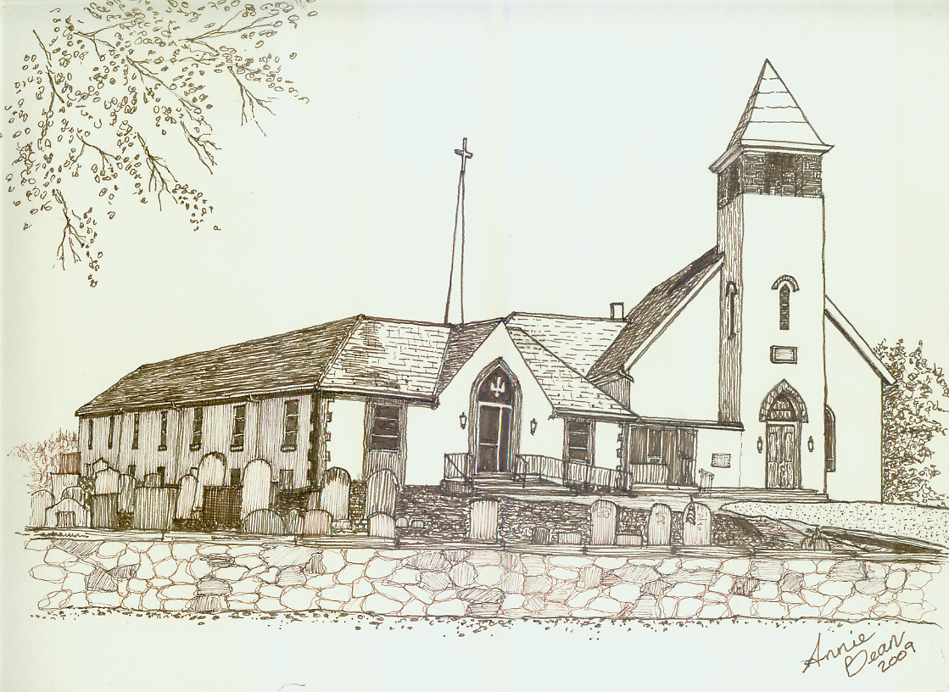

Fourth Sunday after Epiphany
February 2, 2020 10 a.m.
Welcome
We are glad you’re here to worship with us today.
This program has been especially designed
to enable you to participate fully in our Service.
May this be for you a time of refreshment and renewal.

ANNOUNCEMENTS

PRELUDE How Beautiful arr. Larson
Please use this time for quiet meditation before worship.
During the Service, the people will make the responses in the bold print.

CALL TO WORSHIP adapted Psalm 40
All who are able may stand as we open our worship.
Jesus, your teaching surprises us,
not the world’s wisdom, but God’s.

You move us with sorrow for the sorrow of the world.
and make us strong through our tears.

You grace us with humility to admit our failures
and plant seeds of hope in the ashes.

You make us hungry for justice
and give us food that lasts.

You invite us to practice what we preach.
and offer joy in that challenge.

You support us in standing firm for truth,
even when it costs pieces of our lives,
and promise the truth will make us free.

HYMN 580 We Are Called to Be God’s People AUSTRIAN HYMN
After the hymn, please be seated.
INVOCATION
Holy God, meeting you here on this day and in this moment,
we will listen and walk with you,
as we worship together as one.

PRAYER OF BROKENNESS/CONFESSION
The world’s wisdom surrounds us and offers answers:
Look after number one…
Get them before they get you…

Better be safe than sorry…
What’s someone else’s problems got to do with me…?

Only the strong survive…
Money makes the world go ‘round…

Revenge is sweet…
Avoid pain at all costs…

May God forgive us when we,
as Christ’s own people,
believe these words to be life-giving
when Jesus has shown us a much better way.

ASSURANCE OF PARDON
Blessed are those who recognize the wisdom of God,
and strive to shape their lives around its truth.
In Christ, God forgives us and restores us
to the way of trust and mercy.
Thanks be to God.

GLORIA PATRI GLORIA PATRI
Glory be to the Father, and to the Son, and to the Holy Ghost;
as it was in the beginning, is now, and ever shall be,
world without end. Amen. Amen.
THE PEACE
The Peace of Our Lord Jesus Christ be with you.
And also with you.
Let us exchange with one another a sign of Christ’s peace, and then be seated.

PRAYER OF THE DAY

A READING FROM PAUL’S LETTERS 1 Corinthians 1:18-31
Pew Bibles, Page 1772

A READING FROM PSALM 15
Lord, who may dwell in your sacred tent?
Who may live on your holy mountain?
The one whose walk is blameless,
who does what is righteous,
who speaks the truth from their heart;
whose tongue utters no slander,
who does no wrong to a neighbor,
and casts no slur on others;
who despises a vile person
but honors those who fear the Lord;
who keeps an oath even when it hurts,
and does not change their mind;
who lends money to the poor without interest;
who does not accept a bribe against the innocent.
Whoever does these things
will never be shaken.

ANTHEM Holy Ground arr. Larson
Chancel Choir

A WORD FOR ALL AGES
All children may come forward at this time to gather with Pastor Mark.
Those through Grade 6 will then be dismissed to Worship Play.
GOSPEL READING Matthew 5:1-12

SERMON A New Vision Rev. Mark L. Stryjak

HYMN 569 God of Grace and God of Glory CWM RHONDDA
All who are able may stand.
After the hymn, please be seated.

GIVING AND RECEIVING OF TITHES AND OFFERINGS
God has led us to this place to heal and inspire us, to gently redirect us, until we see the world as God does and love it with God’s love.
With our gifts, we affirm that God’s generosity has impacted all of us to do the same, by living into a new creation by the way we give of ourselves.

OFFERTORY Lamb of God arr. Larson

PRESENTATION
All may stand as the offering is presented
and remain standing for the hymns and prayer that follows.

HYMN 34 OLD HUNDREDTH
Praise God from whom all blessings flow;
Praise Him all creatures here below;
Praise Him above, ye heavenly host;
Praise Father, Son, and Holy Ghost. Amen.

PRAYER OF DEDICATION
Thank you, God,
for the opportunity to be in worship
and be able to give in Christ’s name.
In this place now,
and by these gifts,
may we see your love poured out
in generosity and abundance;
and may you grant us hope and courage
to love like we were taught to love
this day and forevermore. Amen.

PRAYER HYMN 493 Cares Chorus
After the hymn, please be seated.

PRAYERS OF THE PEOPLE
Eternal God, in our lives,
the world shows many things to us.
Some of it is very helpful,
but that is also coupled with some that is not.
We pray that our commitment grow to always be the church,
for the people even when the world turns a blind eye.
Many have learned how the world sees individuality as priceless,
but in its shadows lie the huge price to pay for it.
It is with this knowledge today that we come in prayer,
knowing that there is much to pray for.
From wildfires to droughts,
tensions building between nations
and people being forgotten about.
We pray for your world that you created to love each other and not be swallowed up in the belief of power in this world. And in our country God,
we offer prayer for the hungry,
homeless and forgotten,
those in our communities that need us and many more,
to do as your Son taught.
We also pray for those who are closest to us,
our friends, family and this growing congregation.
The joys and concerns are many God,
and now is our time to lift up our joys and concerns to God,
in this moment of silence...
HOLY COMMUNION
Please refer to the laminated insert in the pews.
We invite all who follow Christ to join us in this Holy Communion.
It is our custom to use grape juice in our celebration.

HYMN 436 Grace Alone
All who are able may stand.

BENEDICTION AND CHIMES
As we have learned wisdom, go and teach!
As we have been fed, go to feed the hungry.
As we have been set free, go to set free the imprisoned.
As we have heard, go and proclaim the Good News.
And may the blessing with which you have received
from the Creator, Christ,
and Holy Spirit be with you always. Amen.

POSTLUDE I Will Bless Thee, O Lord arr. Tornquist

As this service comes to an end, our service now begins!
Peace be with all of you!

Response to God's Love – January 26, 2020
Weekly Goal: $3,816
Contributions without endowment support: $7,498.00
Contributions with endowment support: $8,267.00
Attendance: 47 in church 5 in the Nursery



Brownback’s United Church of Christ
640 Ridge Road
Spring City, Pennsylvania 19475
Telephone 610.495.6788
Pastor Stryjak: mark.stryjak@comcast.net or 484-938-7397
Church Email: brownbacksucc@comcast.net
On the Internet at www.brownbackschurch.org

Ministers to the World The Congregation
Pastor and Teacher Rev. Mark L. Stryjak
Consistory President Barry Vining
Consistory Secretary Lara Faust
Financial Secretary Anne Behe
Current Treasurer Holly Vining
Benevolence Treasurer Kaitlin Iezzi
Major Improvement Treasurer Calvin Idler
Endowment Board Chair John Stone
Parish Administrator Kris Houck
Choir Director Penny Sallade
Organist Patricia Kandler
Christian Education Chair Kaitlin Iezzi
Sexton Larry Simmers
Cemetery Superintendent Greg Siwik
Pastor Emeritus Rev. Frank L. Lamson
Pastor Emeritus Rev. Dr. Eugene Grau

