News & Views
Brownback’s United Church of Christ September 2019
Spring City, Pennsylvania

Rally Day

Join us on Sunday, September 8 for our annual kick-off to the faith formation year! The theme this year is a carnival, with lunch and fun after church for all ages. This event promises to be a hit and a great outreach opportunity.

In addition to carnival games, we will also have table games to play with the folks at your table. Enjoy picnic food from some of our favorite grill masters and the Kitchen Committee.

Also enjoy a crowd favorite – a cake walk! Consider bringing a cake or other dessert to donate to the cake walk.

Have you been thinking of inviting a friend or neighbor to our church? This is a great day for visitors to see all the wonderful things Brownback's has to offer!

Calendar of Events

Date | Time | Event
September
8 |  | Rally Day
9 | 8:30 AM | Men’s Breakfast
12 | Noon | Young at Heart
26 |  | News & Views deadline
October
13 | 11:00 AM | Blessing of the Animals
November
9 | 9:00 AM | Church Bazaar
December
8 |  | Children’s Christmas Musical

Recurring Events

Sunday Worship:
8:45 AM – Adult Sunday School (resumes 9/15)
10:00 AM –Worship Service, Worship Time for Children, Kids JAM

Fellowship/Missions:
Community Garden – 6:00 PM, Wednesday

Faith Formation:
Women’s Bible Study – 10:00 AM, Tuesday (resumes 9/17)
Men’s Breakfast – 8:30 AM, 2nd Monday

Music:
Chancel Choir – 9:15 AM, Sunday
Worship Ensemble Rehearsal – 6:00 PM, 3rd Wednesday
Chancel Handbells – 6:45 PM, Wednesday

Fellowship:
Fitness Classes – Monday/Wednesday at 8:45 AM

Pastor’s Ponderings
Hello to all who are reading this portion of the News and Views! My family and I returned from our summer vacation on August 24th and the boys began school on the 26th. This is Logan’s first year as he enters kindergarten and Mikey as a third grader! It was a happy time to watch them get on the bus together, knowing that this is a new normal for all of us.
With that said, I am just returning to the office and the beginning of my work week, and there are a couple of things I would like to highlight. First, is our annual Rally Day, which kicks off the fall and all the Christian education, the continuation of Young at Heart, and the return of our choir!! This big day is September 8th and I hope many can come out to help us celebrate and join in the fun.
As for my work duties, my name was raised to help on the Personnel Committee for the Pennsylvania Southeast Conference, and I have agreed to join the committee. These meetings are every other month on the second Tuesday in the late afternoon. Being able to volunteer within the conference is another way to grow into the spiritual life to which we are all connected, and I look forward to the opportunity to serve.
I will also have a diversity training session that is required by the conference in late September. Right around that same time, we will be rolling out our church’s Vision Plan. This will be a big event – I encourage every member to come out and hear about the plan, and of course join in a wonderful potluck lunch! To sum up this work, the Vision Committee will report on the plan that has been taking shape over the last year based on the feedback provided by all of you. The plan itself will guide our vision and steps forward as we look to grow, both figuratively and spiritually as we all further engage ourselves in God’s work.
I am excited to be a part of this and I believe that it is the best way to grow into the future, moving forward together where we have to lean on trust and our faith in God, as we do not know what God has in store for all of us.
In October, I will be attending the Conference’s second Men’s Clergy Retreat, which is a time of renewal, bonding with other pastors and of course, learning. This year our leader is Rev. Felix Villanueva from the Southern California-Nevada conference of the United Church of Christ. He will be leading us in a dialogue on leading. Leading can be summed up as the opportunity to move others into areas where they may not necessarily wish to go, all in an effort in which to grow. I look forward to reporting back to you all on this time, as I know the resource Dare to Lead, by Brenee Brown, that will be used is very practical.
I think I may have taken up half of our writing space so I will offer more next time. Until then, pray for God to lead you, resist the urge to think you can do it alone or in a better way, and always praise God each and every day.

Peace and Blessings,
Rev. Mark Stryjak

Kids’ Christmas Musical
The Kids' Christmas Musical will take place directly following the Worship Service on Sunday, December 8. This year's show is titled CAKE: Christmas Acts of Kindness, where a group of students is given a group project over Christmas Break that encourages them to show God's love and kindness to all. Mark your calendars to come out and support the kids in sharing a relevant message for all ages! Rehearsals will be starting soon!

Christian Education
It’s that time of year when many of our Christian Education programs resume.

Adult Bible Class
The Adult Bible class meets every Sunday in the church parlor at 8:45 AM. This class will be resuming on September 15 with the series “What In the World Is Going On?” We would love to have you join us.

Women’s Bible Study
The Women’s Bible Study resumes on Tuesday, September 17 at 10:00 AM in the church parlor. Do you like to study the Scriptures? Do you want to know more about the Bible? Are there questions to which you would like answers? Then come and join us on Tuesday mornings. We’ll get to know our Bibles and each other in good fellowship and fun.

Men’s Breakfast
The men of the church are invited to breakfast at The Ridge Restaurant on September 9 at 8:30 AM. Breakfast is BYOB – Bring Your Own Bible. We will discuss Luke 15:1-10.

Nursery Helpers
Thank you to everyone who signed up to volunteer in the Nursery over the course of this next year! Based on the Safe Church Policy, we require two non-married adults to be present in the Nursery each week. With the addition of new little ones at our church, we will need the extra hands. There are still a few slots that need to be filled. Sign up here: https://www.signupgenius.com/go/8050e48ada822a4f85-nursery1

Worship Play Helpers
Calling all adults! No one is too young, old, busy, or inexperienced (or any other excuse you can think of) to help with our children in Worship Play! On the first Sunday of each week, a movie of classic Bible stories will be shown to the kids from a series called Superbook. If you can hit play on a DVD player, you can do this job! On the other weeks, we require two teachers and one assistant. If you don't want to do any prep work, the assistant job is for you! If you can follow a detailed plan provided for you, give teaching a try! We have approximately 11 slots to fill each month, and you can help by signing up here: https://www.signupgenius.com/go/8050E48ADA822A4F85-worship1

Clearances
You may be surprised to learn how easy and FREE it is to obtain your clearances needed to volunteer with our children at church! Follow the directions at the following links and give Kaitlin Iezzi a copy of your clearances:
- PA Criminal History: https://epatch.state.pa.us/
- PA Child Abuse History: https://www.compass.state.pa.us/cwis/public/home
- FBI Fingerprint Clearance (only needed if you lived outside of PA in the last 10 years): https://uenroll.identogo.com/workflows/1KG6ZJ

Cemetery Reminder
A friendly reminder from our Cemetery Board… Any items which are deemed a safety hazard to the lawn service or are not allowed will be removed. Thank you.

Stained Glass Windows
Another project to help maintain our beautiful church building was recently completed under the supervision of the Property Committee. This particular project involved the installation of clear protective glass on the exterior side of the (23) stained glass windows in the Narthex, Sanctuary, and Annex areas.

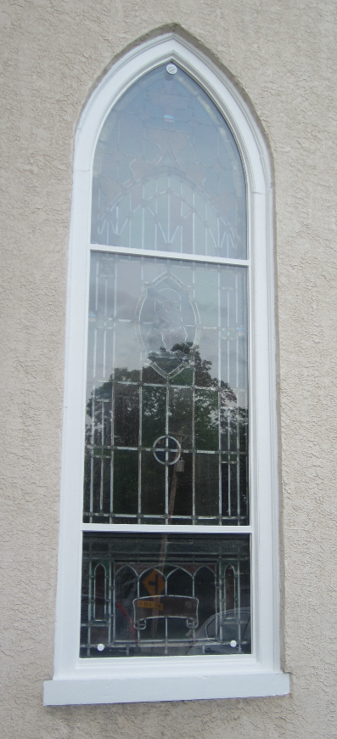
The scope of work included installing ¼” thick clear glass in an aluminum framework cut and bent to fit the custom shape of each window. Small louvered vents were installed top and bottom to prevent heat and moisture build up between the stained glass and the new protective clear glass. The work was completed by Cumberland Stained Glass, Inc. of Mechanicsburg at a cost of $40,300 and took nearly three weeks to complete.

Besides helping protect the stained glass windows from damage, the protective layer seems to make the Sanctuary area much quieter and should also help reduce heating/cooling costs. If you haven’t yet had a chance to check them out, please do so as they are quite well crafted.

Young at Heart Luncheon
at Brownback’s United Church of Christ

World War II Survivor

Presented by

Eleanor Isaacson

Thursday, September 12th
@ Noon
Luncheon $10

RSVP to Peggy Copenhaver by Sunday, Sept. 8th
610-495-6677

Garden Club
The Garden Club will be meeting at the community garden every Wednesday at 6:00 p.m. this summer. We will pull weeds, pick vegetables, and try to solve any and all world problems.

Also, we have picked beets, strawberries, and cherries. The club will sell strawberry jam and cherry jam with proceeds going to missions.

Mission Project: Operation Christmas Child

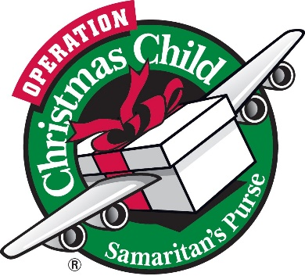
Again, this year, we are involved with packing shoeboxes for Operation Christmas Child, a mission of Franklin Graham, who is the President of Samaritan’s Purse. This is a good way to get involved in the evangelism and discipleship of children around the word and to give them much needed items which they don’t have and can use.

Fill a shoebox with items for a child at home or overseas. Labels, shoeboxes, and a list of unacceptable items and suggested items to pack, are on the table in the Fellowship Hall. We are starting the project now while school supplies, flip flops, and other items are on sale.

Drop off your shoeboxes at Brownback’s during the first week in November (date to be announced) so they can be blessed before being delivered to the drop-off center.

If you have any questions or concerns, Pat Diener or Nancy Peiffer will be able to help you. Enjoy filling a box or two for a child!

Music at Brownbacks
The Brownback’s UCC music season kicks off this week! Rehearsals for the Chancel Choir began on Sunday, followed soon thereafter by Chancel Handbells, Kids’ JAM, and Good News Singers. Consider joining one or more of the following groups! It’s never too late to start. You do not need to sing or perform every week to join a group, and no experience is necessary. Come join in the fun!

Contact Penny Sallade if you have any questions (pennysallade@yahoo.comor 484.985.8234).

Kids’ JAM (first rehearsal – 9/8)
- All kids through 6th grade
- Rehearse: Sundays during Worship Play
- Perform: 1st Sunday of the month
Chancel Choir (first rehearsal – 8/25)
- Harmonized music
- Adults and youth in at least 6th grade
- Rehearse: Sundays at 9:15 AM
- Perform: 1st, 2nd, and 3rd Sundays
Good News Singers (first rehearsal – 9/18)
- Unison singing
- Adults and youth in at least 6th grade
- Rehearse: 3rd Wednesday at 6:00 PM
- Perform: 4th Sunday
Chancel Handbells (first rehearsal – 8/28)
- Adults and experienced youth in at least 6th grade
- Rehearse: Wednesdays at 6:45 PM
- Perform: 3rd Sunday

Youth Handbells (first rehearsal – early October)
- Children in 1st through 12th grades
- Rehearse: Scheduled Sundays after church
- Perform: 5-6 times per year

In addition, the Worship Ensemble will perform on the 2nd and 5th Sundays each month. This year we hope to incorporate some additional instruments (flute, violin).

Congratulations
Congratulations to Scott, Jen, and Deacon Wysocki on the birth of Preston Scott on July 11 at 7:50 pm. Preston weighed 8 lb 4 oz and was 21” long. Mama and baby are doing well.

Kudos
Kudos to our following members:

Trevor Ford
Congratulations to Trevor Ford for being accepted to West-Mont Christian Academy. Trevor will begin 5th grade in the Fall.

Brooke Radel
Congratulations to Brooke Radel, who played the part of Elsa in the Stage Chasers performance of Frozen Jr. this summer. The musical was performed at Owen J. Roberts High School by cast members of ages 11-17. Brooke and the entire cast gave a wonderful performance.

Daily Walk With God
10. Giving
This month we are going to move into a practice that is beyond our prayer time that we have set aside each week. Although we will continue with that time of prayer, our practice for this month moves us out of that space and into our daily lives. This month we are going to participate in the practice of fasting and almsgiving. I encourage you to think how you can fast from some activity or food and then how you can donate the resulting time or resources. Among the possibilities for fasting are food items, watching television, unnecessary consuming or shopping, talking about people who are not present, or unnecessary speaking. I will give you some examples that I or my classmates did when participating in this class last year. I decided to fast from busyness for at least 1 hour each Sat. What I meant by this is I wouldn’t do any housework, homework, be on my phone or participate in some other “responsibility.” This hour I gave up each week was then given to my sons. We spent time doing arts and crafts, baking or just being together. I gave up “what I could be doing” and instead gave the attention to my children intentionally each week.

If you give up unnecessary shopping, you could give the money you would have spent to a charity, church, or some other meaningful cause. You could also give the time you would have spent shopping back in some way; through volunteering, helping a friends, or using it for Sabbath. If you fast from unnecessary speaking, you can focus more on listening in a conversation with others than thinking about your own response. Giving up some TV can give you more time for others or prayer. This is the idea behind the practice. So be creative because this is an opportunity to explore new territory.

Please allow your fasting to foster your time in prayer. Use your prayer time each week to reflect on your fasting and almsgiving. See the ways in which God is speaking to you through this practice or reflect on the ways in which fasting is a challenge or a blessing. Use this practice to deepen your time in prayer and your relationship with God.

Happy Fasting,
Chaplain Rev. Kimberly Stryjak

Neighbors in Need
Neighbors in Need (NIN) is a special mission offering of the United Church of Christ that supports ministries of justice and compassion throughout the United States. One-third of NIN funds support the Council for American Indian Ministry (CAIM). Two-thirds of this offering is used by the UCC's Justice and Witness Ministries (JWM) to support a variety of justice initiatives, advocacy efforts, and direct service projects through grants. Neighbors in Need grants are awarded to UCC churches and organizations doing justice work in their communities. These grants fund projects whose work ranges from direct service to community organizing and advocacy to address systemic injustice. This year, special consideration will be given to projects focusing on serving our immigrant neighbors and communities.

Most UCC congregations, including Brownback’s UCC, will receive the NIN offering on October 6 as part of their World Communion Sunday observance. You can make a donation using your special Neighbors in Need Offering envelope, or you can donate online at the United Church of Christ website: https://www.ucc.org/nin

News & Views Deadline
The deadline for the October issue of the News & Views newsletter is September 26. To include information in the newsletter, you can leave information in the News & Views mailbox in the church lobby or email information to Penny Sallade at pennysallade@yahoo.com.

Paper and Plastic Grocery Bags
The Spring City Food Pantry is in critical need of paper and plastic grocery bags (particularly paper bags). Please consider donating your used bags at church to be delivered to the pantry. Boxes are labeled and located under the table at the back of Fellowship Hall.

Church Bazaar – Save the Date
Mark your calendars now for the annual church bazaar on Saturday, November 9, from 9:00 am to 2:00 pm. Lunch is served from 11:00 am to 1:00 pm. The Fellowship Hall will be filled with attic treasures, baked goods, crafts, toys, plants, and books.

Donations for attic treasures may be placed on the stage behind the curtain. Please be sure that donations are in working order and CLEAN. Given the volume of donations, the team does not have time to clean dirty donations.

We cannot accept donations of electronic devices such as televisions and computers. Due to safety regulations, we are also unable to accept baby car seats and booster seats.

In Honor of Our College Students Returning to Classes

You might be a college student if…

- You have price-shopped for ramen noodles.
- You consider Mac & Cheese a balanced meal.
- You have Venmo’d someone $1.50.
- Caffeine is a major food group.
- You have seen two consecutive sunrises, without sleep.
- You wake up 10 minutes before class begins.
- You’ve pulled something out of your hamper and worn it again because doing laundry takes too much time.
- Your midnight snack is microwave popcorn.
- You’ve become a pro at whipping out papers and projects the night before they are due.
- You can squeeze a nap into any break in your schedule. One hour? Definitely. 30 minutes? No problem. Seven minutes? Doable.

Prayer Concerns
“And whatever you ask in prayer, you will receive, if you have faith.” –Matthew 21:22

For those who serve:
- Reed Bauer, 2nd year cadet at West Point, The United States Military Academy
- Derrick Boaman, Army Reserves
- Nathaniel Cherubini, Chief Warrant Officer 3.,
United States Marine Corp. Nephew of Rick and Jeanette Francesco
- Brock Fasnacht, nephew of Doug and Sue Kandler, Army National Guard
- Paige Juliette Freeman, Trooper First Class, Delaware State Police
- Andrea Shade, 4th year cadet at West Point, The United States Military Academy
- Thomas Shade, Captain in the Army based in South Carolina

Members: Ryan Copenhaver, Joe Kandler, Sr., Bob Keeley, Sr., Bob Miller, Thelma Nelson, Marie Painter, Judy White.

Friends of Brownback’s: Gary Conover, Eva Diener, Jim Fitch, Grace Flynn, Alison Hughes, Sean Mahoney, Christopher Milecki, Marge Montgomery, Mike Sands, Craig Warwood, Diane Weaver.

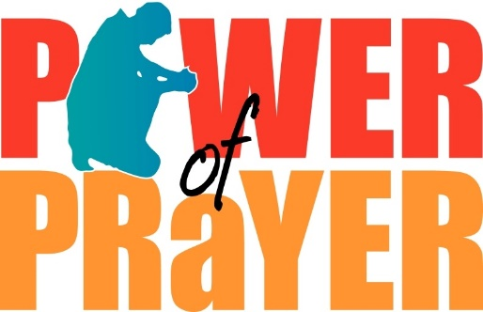

Did you know…

…that Penn State is one of the most popular schools for future executives, as it places second, behind only Stanford, in number of graduating CEOs?
…that worldwide, a third of all food is lost or thrown away each year? –according to the U.N.’s Food and Ag Organization
…that by 2050, two-thirds of the world’s population will live in urban areas, according to the United Nations?
…that there are almost 8 million possible seven-digit phone numbers per area code?
…that chewing gum is banned in Singapore?
…that the first item sold on eBay was a broken laser pointer?
_____________________________________________

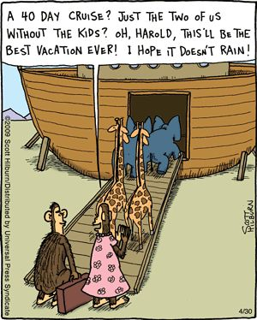

September Birthdays
We rejoice with those of our church family who are celebrating birthdays in September.

9/1 Madison Kurtz
Denise Maciora
9/5 Terry Overholtzer
9/6 Jacob Thompson
9/8 Alicia Ruilova
9/10 Rosalie Pallay
Jack Stone
9/11 Doug Kandler
9/14 Linda Burke
Dorothy Keck
9/15 Polly Roussey
9/20 Bill Marvel, Sr.
9/21 Thomas Shade
9/22 Grace Beitler
9/25 John Stout
9/26 Kurt Spiess
9/28 Claudia Diener
Mary Ann Ronan-Lamson
Richard Trythall
9/30 Richard Francesco
Dennis Miller

September Anniversaries
We congratulate the following in our church family who are celebrating wedding anniversaries in September.

9/7 Buzz and Vickie Bradley
9/12 Karl and Mary Ann Glocker
9/13 Michael and Alicia Vento
9/14 Scott and Jen Wysocki

Our Church Leaders
Rev. Mark Stryak, Pastor and Teacher
Barry Vining, President
Linda Raifsnider, Vice President
Amy Stone, Secretary
Anne Behe, Financial Secretary
Holly Vining, Current Treasurer
Kaitlin Iezzi, Benevolence Treasurer
Calvin Idler, Major Improvements Treasurer

Elders
2019 Pat Diener Linda Raifsnider
2020 Earl Brungess Barry Vining
2021 Randall Ruilova Mark Sweitzer

Deacons
2019 Amy Stone Polly Roussey
2020 Derrick Boaman Kaitlin Iezzi
2021 Calvin Idler Anne Behe

Cemetery Board
2019 Calvin Idler Bob Jacob
2020 Rick Francesco
2021 Brian Iezzi Greg Siwik

Endowment Board
2019 Rich Bauer John Stone
2020 Mike Houck
2021 Bob Keeley Barry Vining

Our Church Staff
Kris Houck, Parish Administrator
Penny Sallade, Choir Director
Patricia Kandler, Organist
Larry Simmers, Sexton
Kaitlin Iezzi, Christian Education Chair
Greg Siwik, Cemetery Superintendent

Brownback United Church of Christ
640 Ridge Road
Spring City, Pennsylvania 19475

Address Service Requested

